**VISVESVARAYA TECHNOLOGICAL UNIVERSITY**

**“JnanaSangama”, Belgaum -590014, Karnataka.**



**LAB REPORT**

**on**

**Artificial Intelligence (23CS5PCAIN)**

***Submitted by***

**Tutari Likitha (1BM22CS312)**

***in partial fulfillment for the award of the degree of***

**BACHELOR OF ENGINEERING**

***in***

**COMPUTER SCIENCE AND ENGINEERING**



**B.M.S. COLLEGE OF ENGINEERING**

**(Autonomous Institution under VTU)**

**BENGALURU-560019**

**Sep-2024 to Jan-2025**

**B.M.S. College of Engineering,**

**Bull Temple Road, Bangalore 560019**

(Affiliated To Visvesvaraya Technological University, Belgaum)

**Department of Computer Science and Engineering**



**CERTIFICATE**

This is to certify that the Lab work entitled “Artificial Intelligence (23CS5PCAIN)” carried out by **Tutari Likitha (1BM22CS312),** who is bonafide student of **B.M.S. College of Engineering.** It is in partial fulfillment for the award of **Bachelor of Engineering in Computer Science and Engineering** of the Visvesvaraya Technological University, Belgaum. The Lab report has been approved as it satisfies the academic requirements in respect of an Artificial Intelligence (23CS5PCAIN) work prescribed for the said degree.

| Prameetha Pai  Assistant Professor  Department of CSE, BMSCE | Dr. Kavitha Sooda  Professor & HOD  Department of CSE, BMSCE |
| --- | --- |

**Index**

| **Sl.**  **No.** | **Date** | **Experiment Title** | **Page No.** |
| --- | --- | --- | --- |
| 1 | 04-10-2024 | Implement Tic –Tac –Toe Game | 4-7 |
| 2 | 18-10-2024 | Implement vacuum cleaner | 8-10 |
| 3 | 18-10-2024 | Implement 8 puzzle problems using Depth First Search (DFS)  Implement Iterative deepening search algorithm | 11-18 |
| 4 | 25-10-2024 | Implement A* search algorithm | 19-27 |
| 5 | 08-11-2024 | Implement Hill Climbing search algorithm to solve N-Queens problem | 28-30 |
| 6 | 15-11-2024 | Simulated Annealing to Solve 8-Queens problem | 31-34 |
| 7 | 22-11-2024 | Implement unification in first order logic | 35-38 |
| 8 | 2-12-2024 | Create a knowledge base consisting of first order logic statements and prove the given query using Resolution. | 38-41 |
| 9 | 16-12-2024 | Create a knowledge base consisting of first order logic statements and prove the given query using forward reasoning. | 42-44 |
| 10 | 16-12-2024 | Converting First Order Logic to CNF | 45-46 |
| 11 | 16-12-2024 | Implement Alpha-Beta Pruning. | 47-50 |

Github Link:

https://github.com/likitha-zzie/AI-LAB

**Program 1**

**Implement Tic –Tac –Toe Game**

**Algorithm:**

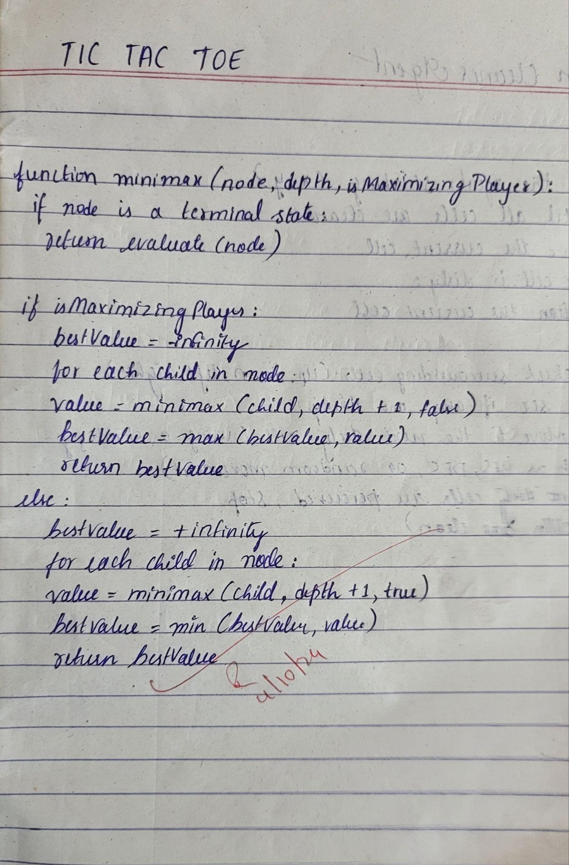

**Code:**

# Initialize the board

board = [' ' for _ in range(9)]

# Function to draw the board

def draw_board():

row1 = '| {} | {} | {} |'.format(board[0], board[1], board[2])

row2 = '| {} | {} | {} |'.format(board[3], board[4], board[5])

row3 = '| {} | {} | {} |'.format(board[6], board[7], board[8])

print()

print(row1)

print(row2)

print(row3)

print()

# Function for player's move

def player_move(icon):

if icon == 'X':

number = 1

elif icon == 'O':

number = 2

print("Your turn, player {}".format(number))

choice = int(input("Enter your move (1-9): ").strip())

if board[choice - 1] == ' ':

board[choice - 1] = icon

else:

print()

print("That space is taken!")

# Function to check for victory

def is_victory(icon):

if (board[0] == icon and board[1] == icon and board[2] == icon) or \

(board[3] == icon and board[4] == icon and board[5] == icon) or \

(board[6] == icon and board[7] == icon and board[8] == icon) or \

(board[0] == icon and board[3] == icon and board[6] == icon) or \

(board[1] == icon and board[4] == icon and board[7] == icon) or \

(board[2] == icon and board[5] == icon and board[8] == icon) or \

(board[0] == icon and board[4] == icon and board[8] == icon) or \

(board[2] == icon and board[4] == icon and board[6] == icon):

return True

else:

return False

# Function to check for a draw

def is_draw():

if ' ' not in board:

return True

else:

return False

# Function to play the game

def play_game():

draw_board()

while True:

player_move('X')

draw_board()

if is_victory('X'):

print("Player 1 wins! Congratulations!")

break

elif is_draw():

print("It's a draw!")

break

player_move('O')

draw_board()

if is_victory('O'):

print("Player 2 wins! Congratulations!")

break

elif is_draw():

print("It's a draw!")

break

# Start the game

play_game()

**Output:**

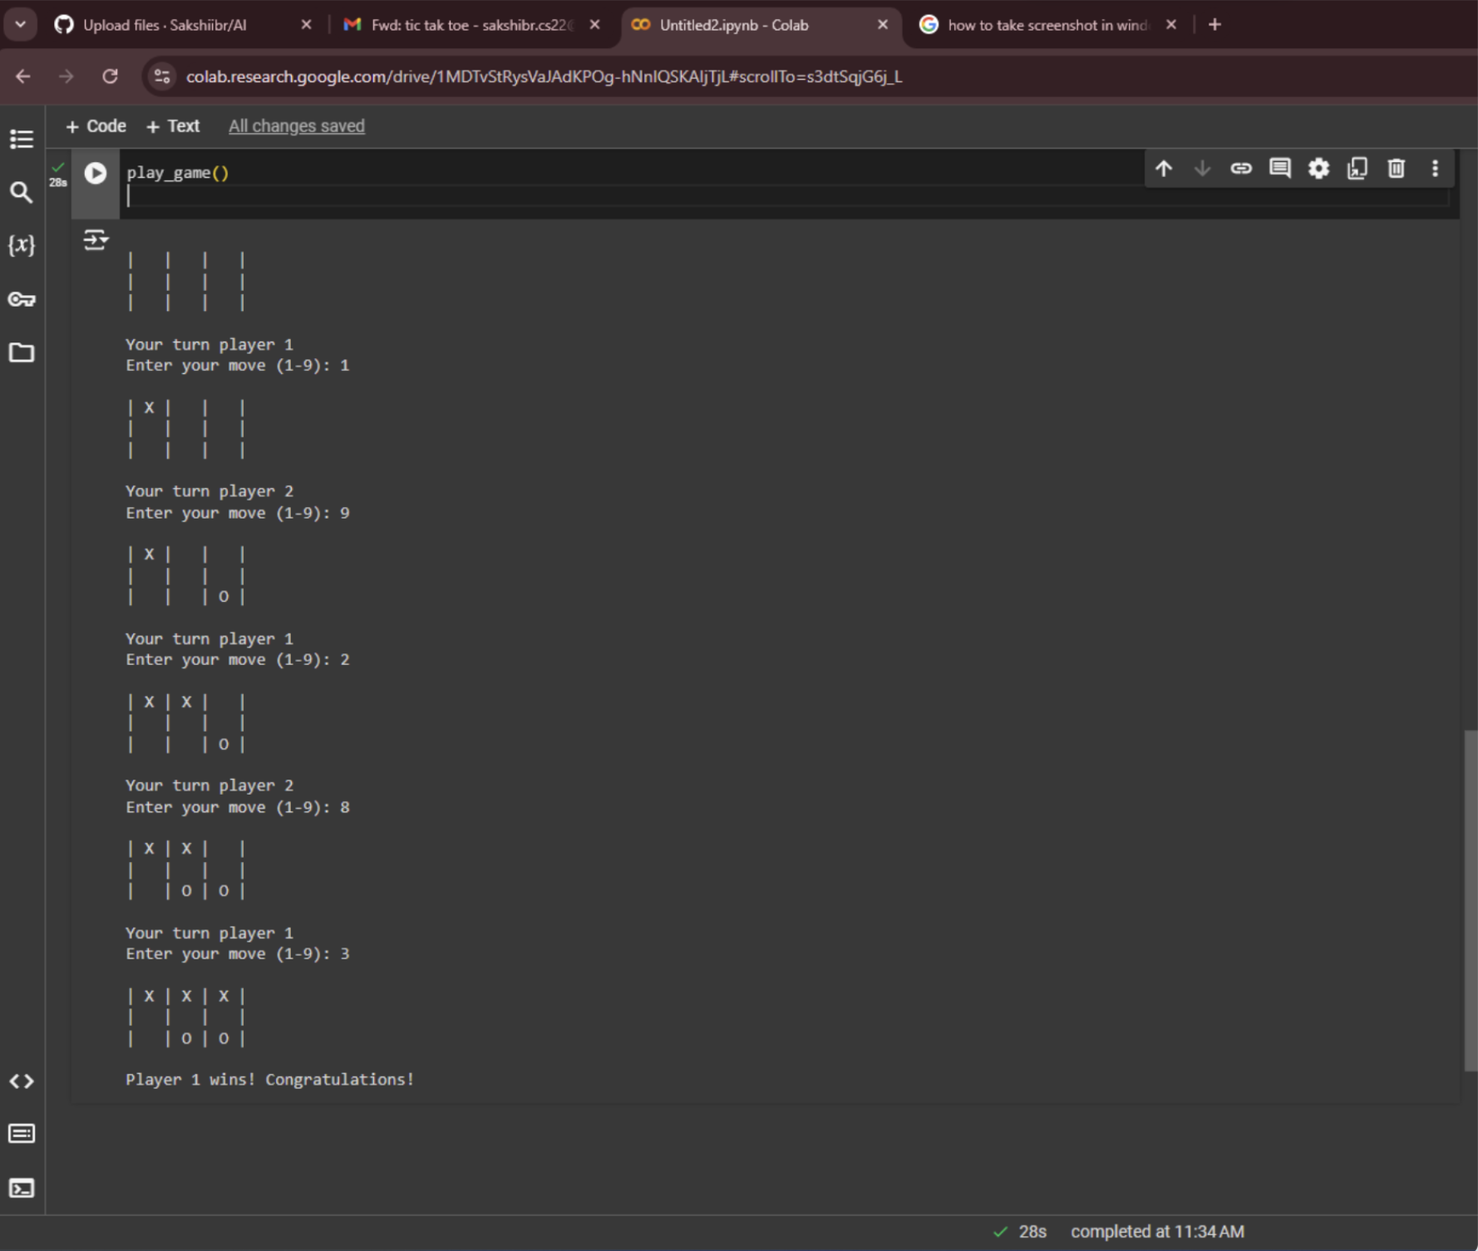

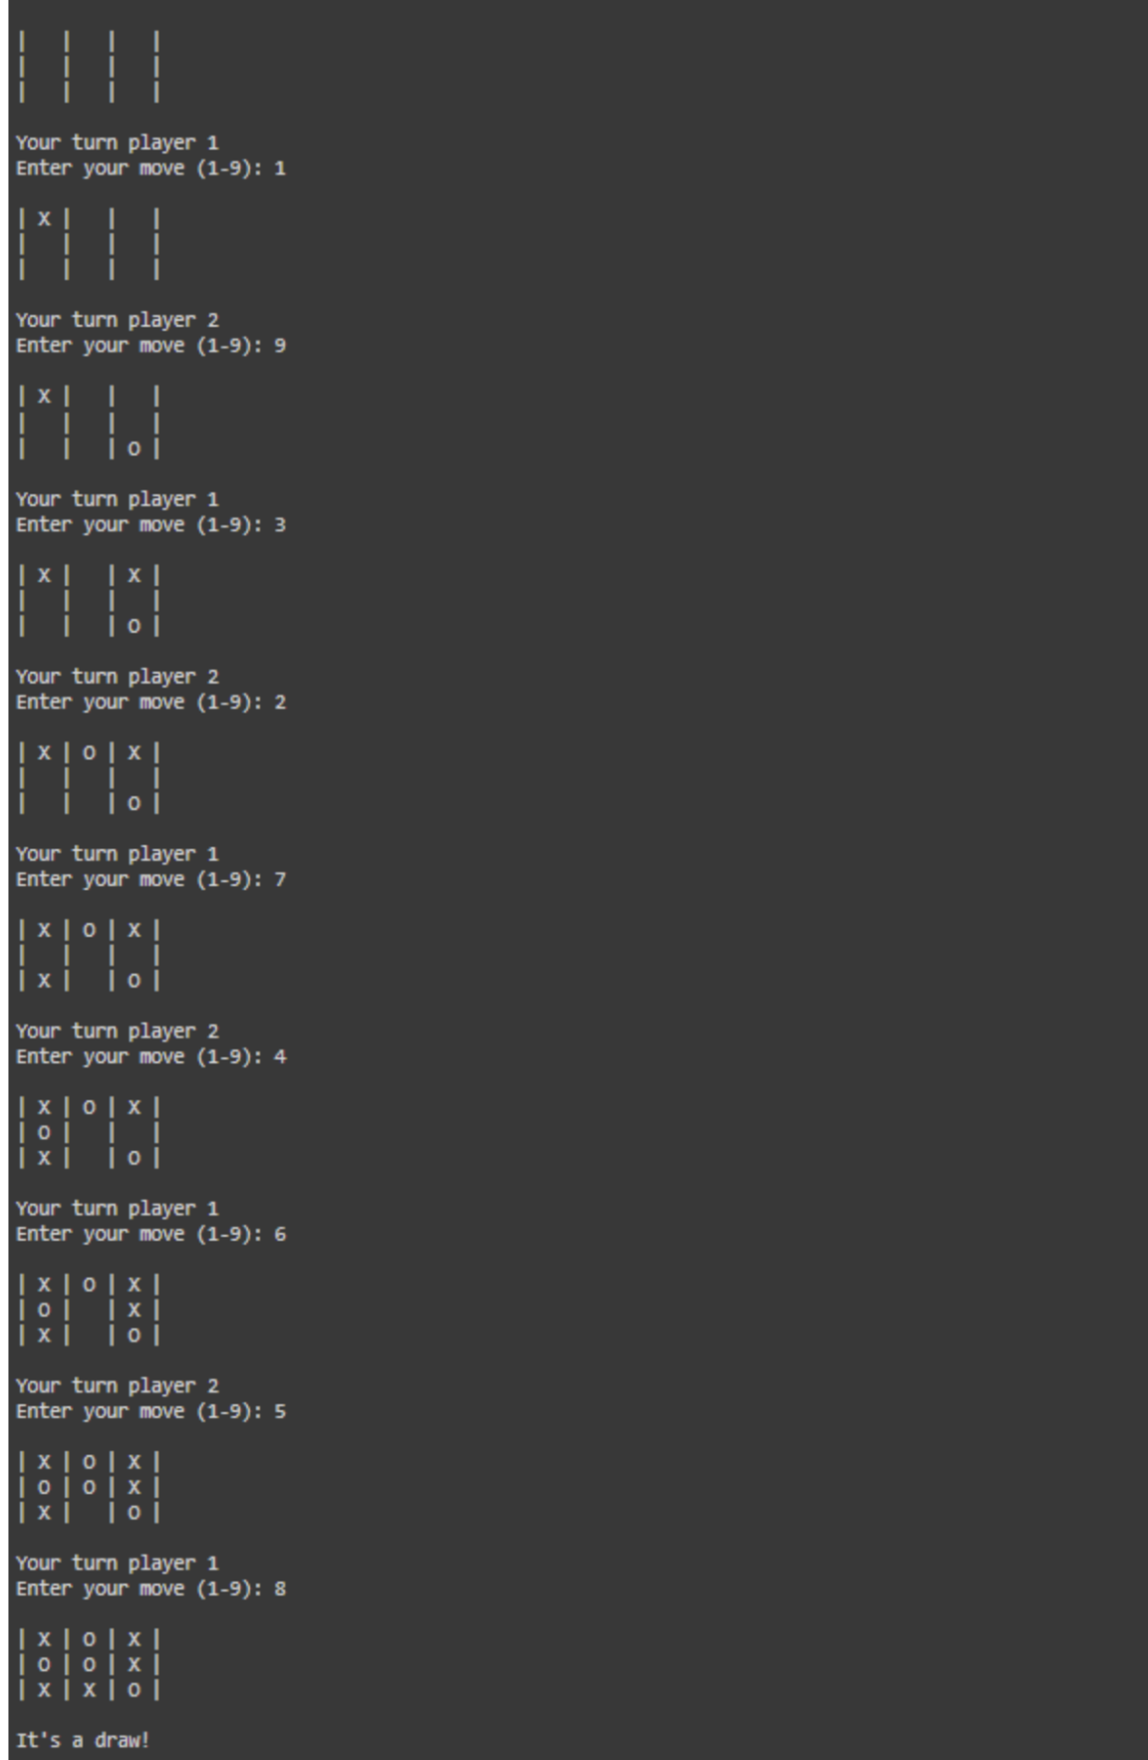

**Program 2**

**Implement vacuum cleaner agent**

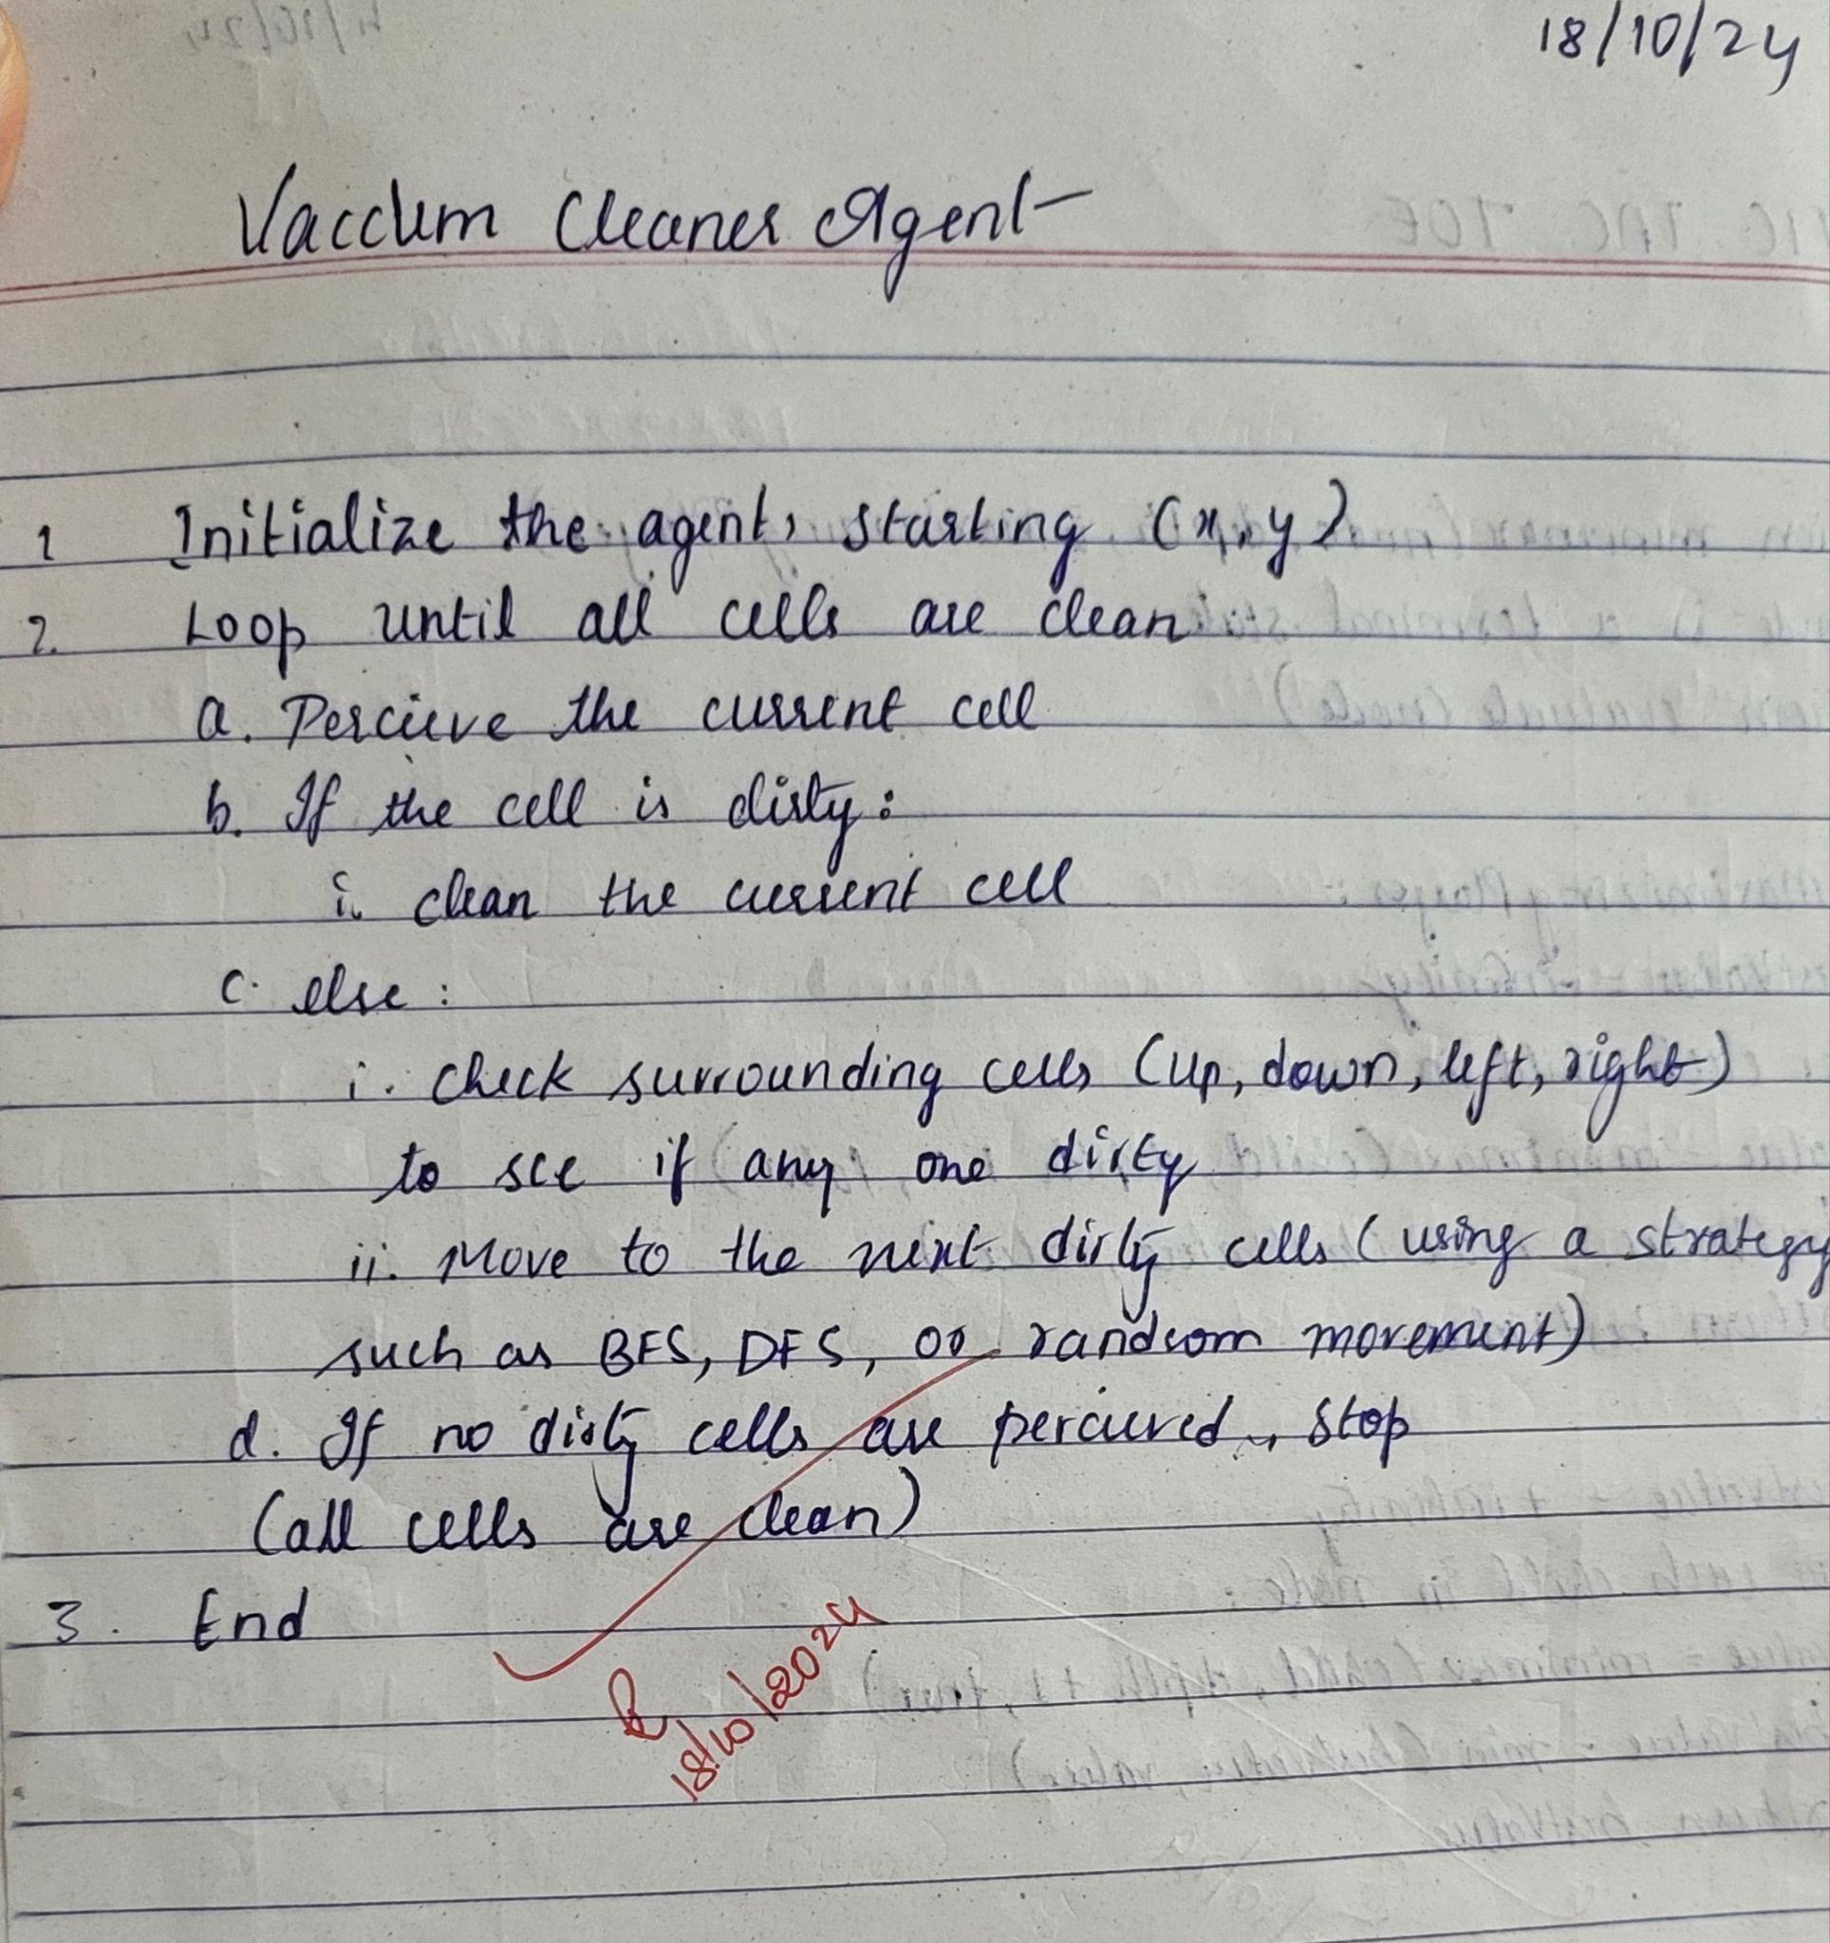

**Code:**

# Reflex function for vacuum cleaner

def reflex(loc, status, cost):

s = status # Track the current status of the location

if status == 1: # If the location is dirty

cost += 1

print(f"SUCK at {loc}")

s = 0 # The location is now clean

if loc == "A":

print("Move RIGHT to B")

loc = "B" # Move to B

elif loc == "B":

print("Move LEFT to A")

loc = "A" # Move to A

return cost, loc, s # Return updated cost, location, and status

# Function to check goal state

def goal(a_status, b_status):

if a_status == 0 and b_status == 0:

print("Goal reached")

else:

print("Goal not reached")

# Input for the starting location and statuses

loc = input("Enter the starting location of the vacuum (A or B): ").strip()

cost = 0

a_status = int(input("Enter the status of location A (0 for clean, 1 for dirty): "))

b_status = int(input("Enter the status of location B (0 for clean, 1 for dirty): "))

# Simulate cleaning process

if loc == "A":

cost, loc, a_status = reflex("A", a_status, cost)

cost, loc, b_status = reflex("B", b_status, cost)

elif loc == "B":

cost, loc, b_status = reflex("B", b_status, cost)

cost, loc, a_status = reflex("A", a_status, cost)

# Output the total cost and goal status

print(f"Total cost: {cost}")

goal(a_status, b_status)

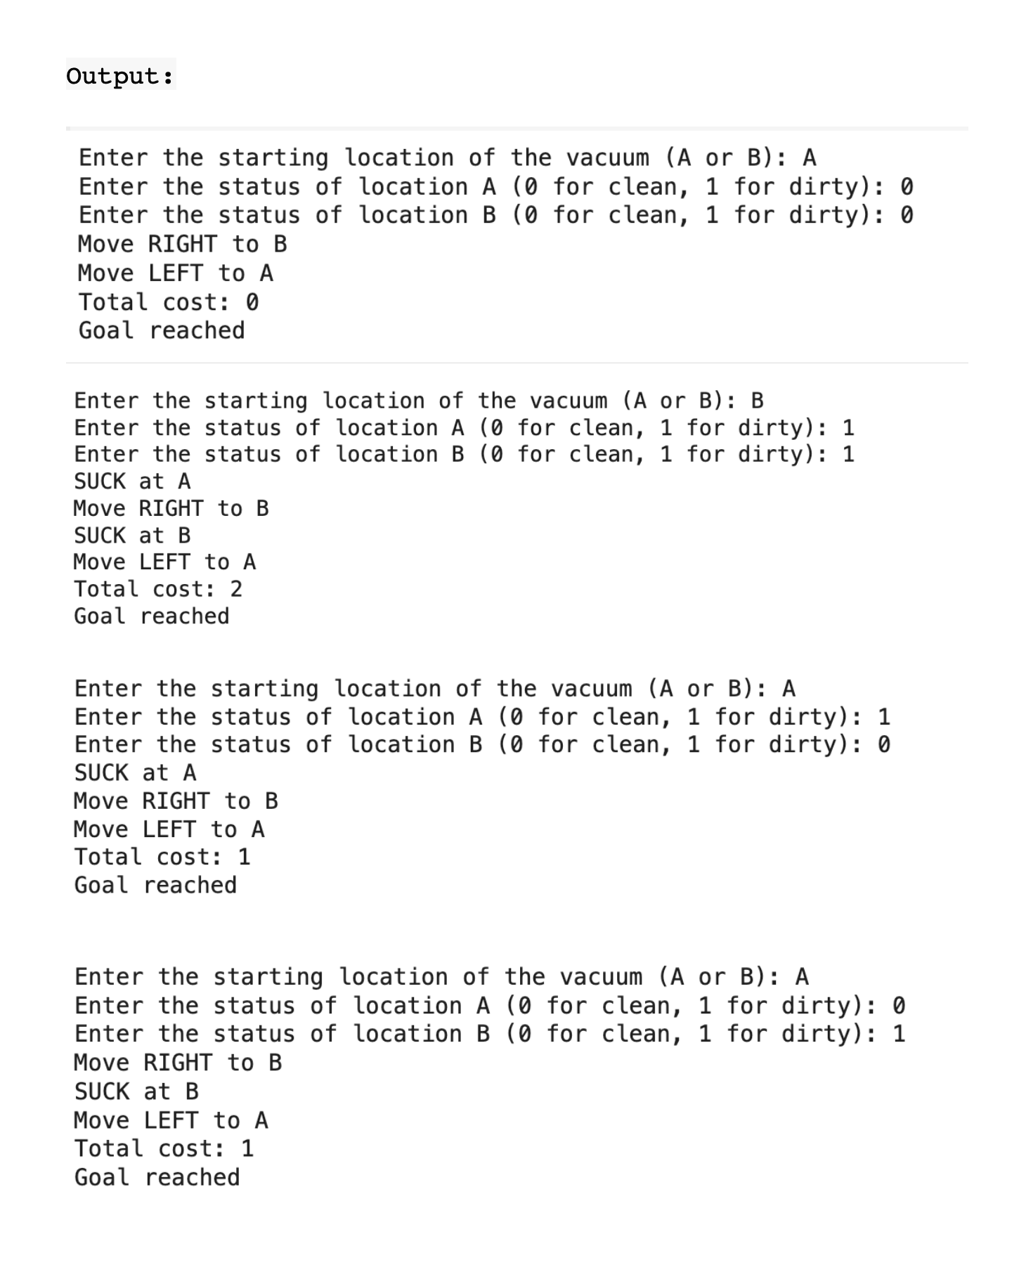

**Program 3**

**Implement 8 puzzle problems using DFS and BFS:**

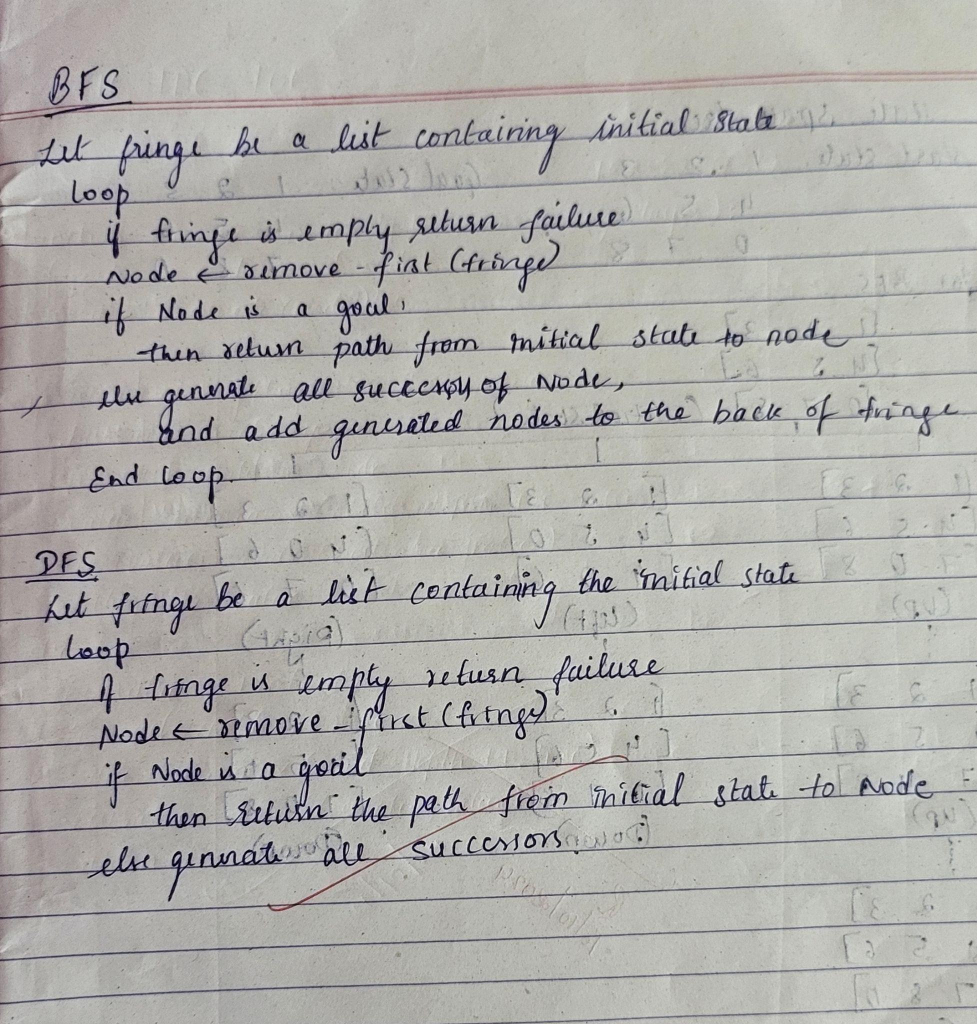

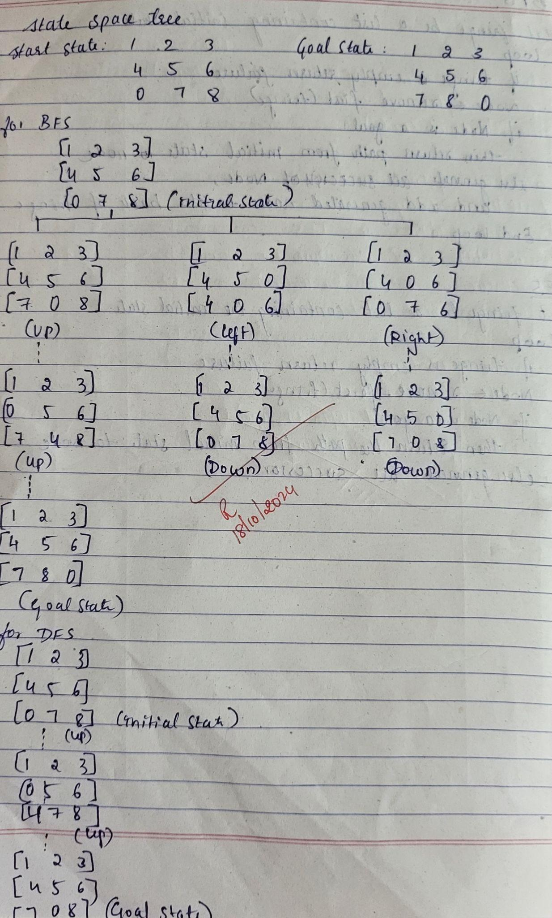

**Code:**

**BFS:**

from collections import deque

# Goal state for the 8-puzzle

goal_state = [[1, 2, 3],

[4, 5, 6],

[7, 8, 0]]

# Possible moves

moves = {'up': (-1, 0), 'down': (1, 0), 'left': (0, -1), 'right': (0, 1)}

# Function to find the position of the blank (0)

def find_blank(state):

for i in range(len(state)):

for j in range(len(state[i])):

if state[i][j] == 0:

return i, j

# Function to check if a state is the goal state

def is_goal(state):

return state == goal_state

# Function to generate neighbors by moving the blank tile

def get_neighbors(state):

neighbors = []

blank_row, blank_col = find_blank(state)

for move, (dr, dc) in moves.items():

new_row, new_col = blank_row + dr, blank_col + dc

if 0 <= new_row < 3 and 0 <= new_col < 3:

# Create a new state by swapping tiles

new_state = [row[:] for row in state]

new_state[blank_row][blank_col], new_state[new_row][new_col] = new_state[new_row][new_col], new_state[blank_row][blank_col]

neighbors.append((new_state, move))

return neighbors

# Function to print the puzzle state

def print_puzzle(state):

for row in state:

print(row)

print()

# BFS algorithm to solve the puzzle

def bfs(start_state):

queue = deque([(start_state, [])]) # Queue stores (current state, path to reach it)

visited = set() # To avoid revisiting states

visited.add(tuple(tuple(row) for row in start_state)) # Convert state to a tuple for hashing

while queue:

current_state, path = queue.popleft()

# Check if the goal is reached

if is_goal(current_state):

return current_state, path

# Explore neighbors

for neighbor, move in get_neighbors(current_state):

state_tuple = tuple(tuple(row) for row in neighbor)

if state_tuple not in visited:

visited.add(state_tuple)

queue.append((neighbor, path + [move]))

return None, None

# Function to get user input for the initial state

def get_user_input():

print("Enter the initial state of the 8-puzzle (row by row):")

state = []

for i in range(3):

while True:

try:

row = list(map(int, input(f"Enter row {i+1} (3 integers, space-separated): ").split()))

if len(row) != 3 or any(x not in range(9) for x in row):

raise ValueError

state.append(row)

break

except ValueError:

print("Invalid input. Please enter 3 integers between 0 and 8.")

return state

# Function to demonstrate the solution step by step

def demonstrate_solution(start_state, solution_path):

current_state = start_state

print("Initial state:")

print_puzzle(current_state)

for move in solution_path:

print(f"Move: {move}")

for neighbor, move_name in get_neighbors(current_state):

if move_name == move:

current_state = neighbor

print_puzzle(current_state)

break

# Main function

if __name__ == "__main__":

start_state = get_user_input()

final_state, solution_path = bfs(start_state)

if solution_path:

print("Solution found. Steps are demonstrated below:")

demonstrate_solution(start_state, solution_path)

else:

print("No solution found.")

**Output:**

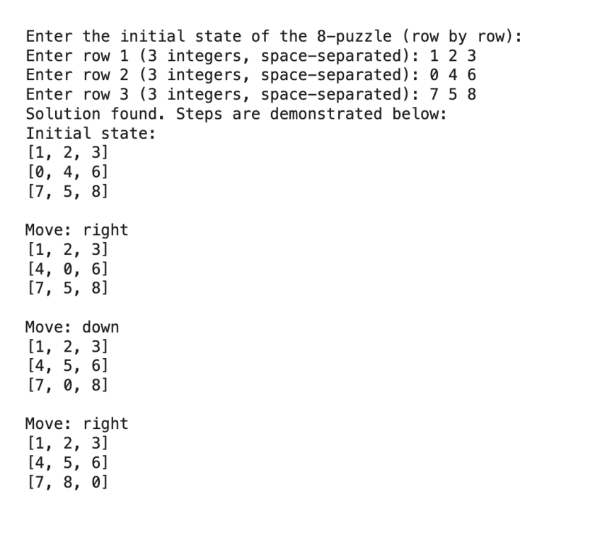

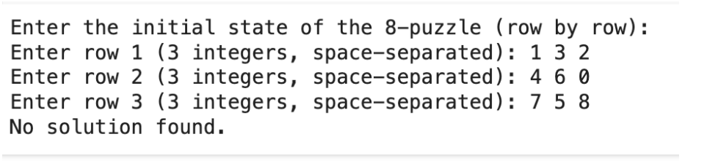

**DFS:**

from copy import deepcopy

# Directions for moving the blank space (0): up, down, left, right

DIRECTIONS = [(-1, 0), (1, 0), (0, -1), (0, 1)]

class PuzzleState:

def __init__(self, board, parent=None, move=""):

self.board = board

self.parent = parent

self.move = move

# Find the position of the blank (0)

def get_blank_position(self):

for i in range(3):

for j in range(3):

if self.board[i][j] == 0:

return i, j

# Generate successor states by moving the blank space

def generate_successors(self):

successors = []

x, y = self.get_blank_position()

for dx, dy in DIRECTIONS:

new_x, new_y = x + dx, y + dy

if 0 <= new_x < 3 and 0 <= new_y < 3:

new_board = deepcopy(self.board)

new_board[x][y], new_board[new_x][new_y] = new_board[new_x][new_y], new_board[x][y]

successors.append(PuzzleState(new_board, parent=self))

return successors

# Check if the current state matches the goal state

def is_goal(self, goal_state):

return self.board == goal_state

# String representation of the puzzle state

def __str__(self):

return "\n".join([" ".join(map(str, row)) for row in self.board])

# Depth-limited search (DLS)

def depth_limited_search(current_state, goal_state, depth):

if depth == 0 and current_state.is_goal(goal_state):

return current_state

if depth > 0:

for successor in current_state.generate_successors():

found = depth_limited_search(successor, goal_state, depth - 1)

if found:

return found

return None

# Iterative deepening search (IDS)

def iterative_deepening_search(start_state, goal_state):

depth = 0

while True:

print(f"\nSearching at depth level: {depth}")

result = depth_limited_search(start_state, goal_state, depth)

if result:

return result

depth += 1

# Get user input for start and goal states

def get_user_input():

print("Enter the start state (use 0 for the blank):")

start_state = []

for _ in range(3):

row = list(map(int, input().split()))

start_state.append(row)

print("Enter the goal state (use 0 for the blank):")

goal_state = []

for _ in range(3):

row = list(map(int, input().split()))

goal_state.append(row)

return start_state, goal_state

# Main function

def main():

start_board, goal_board = get_user_input()

start_state = PuzzleState(start_board)

goal_state = goal_board

result = iterative_deepening_search(start_state, goal_state)

if result:

print("\nGoal reached!")

path = []

while result:

path.append(result)

result = result.parent

path.reverse()

for state in path:

print(state, "\n")

else:

print("Goal state not found.")

if __name__ == "__main__":

main()

**Output:**

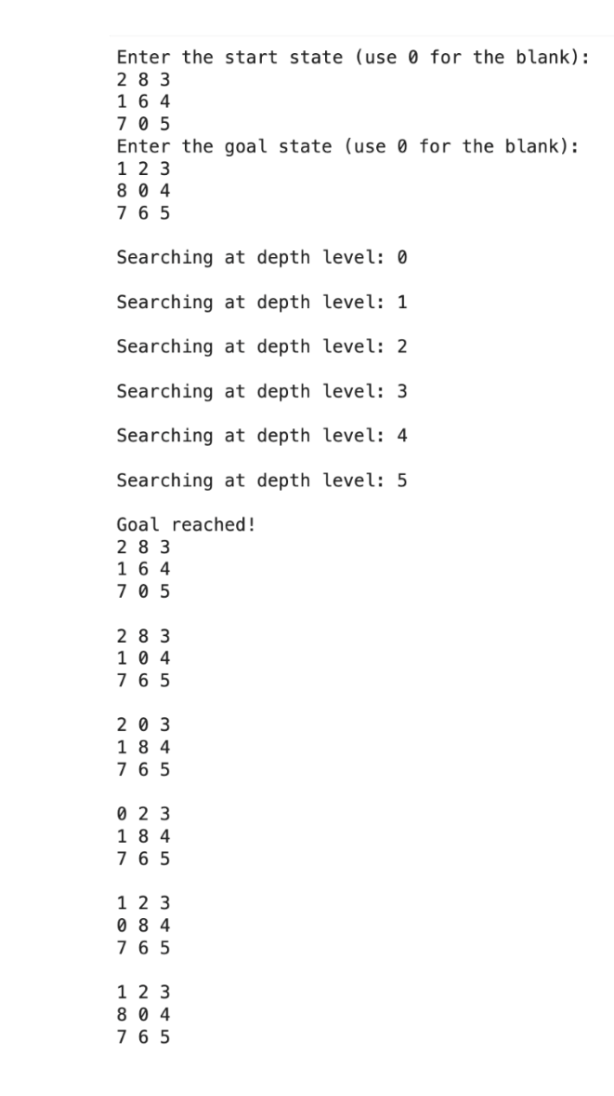

**Program 4**

**Implement A* search algorithm**

**Algorithm:**

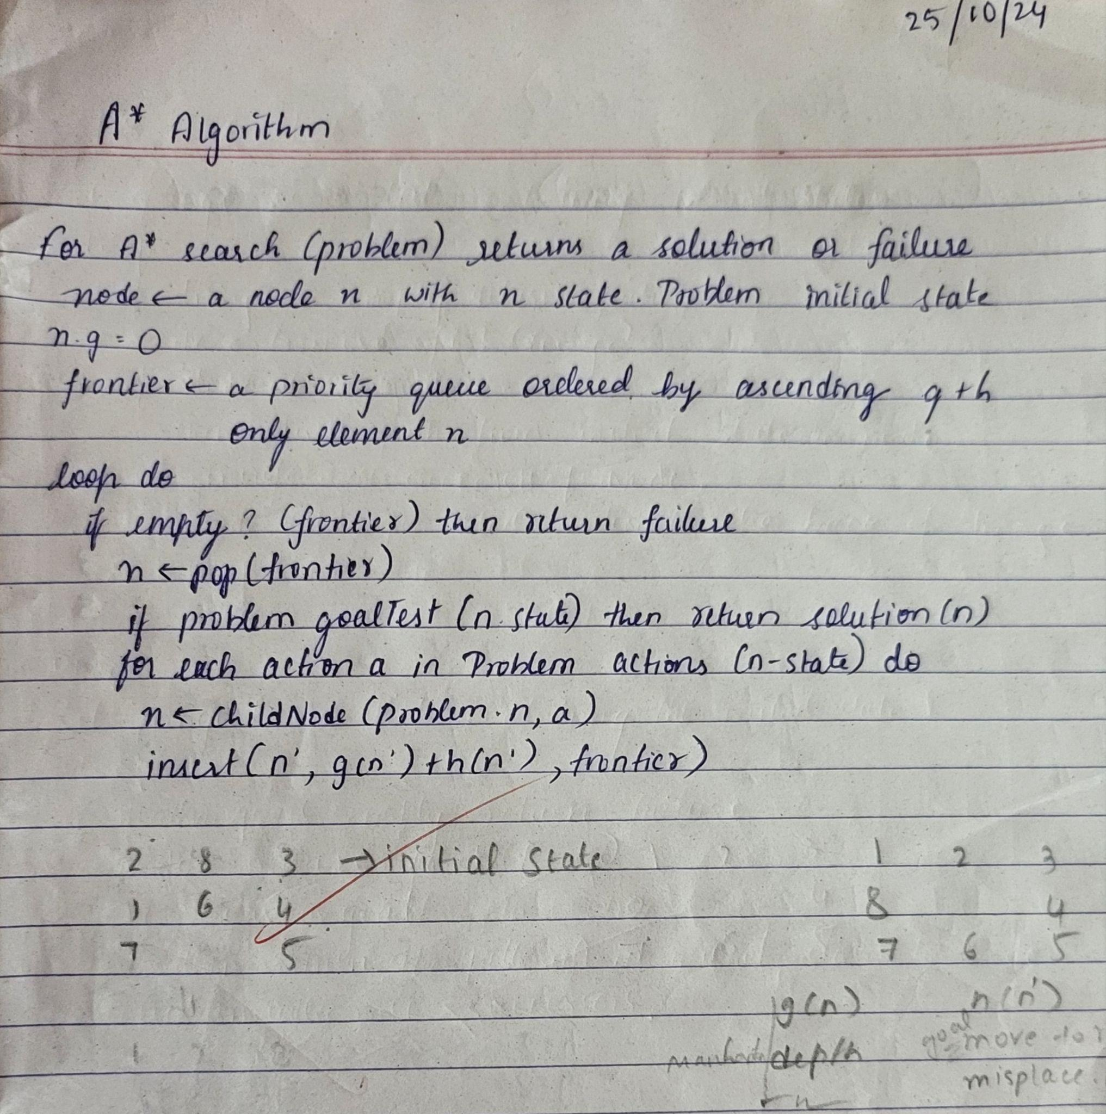

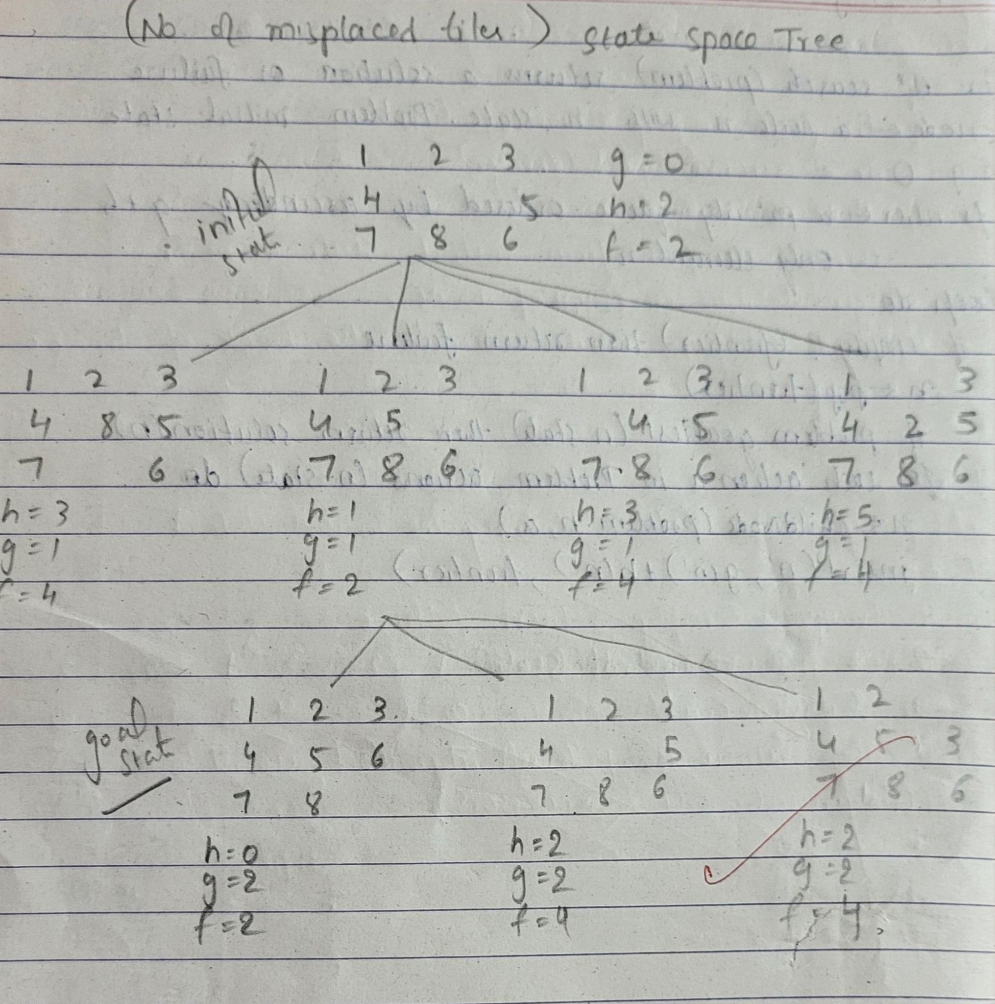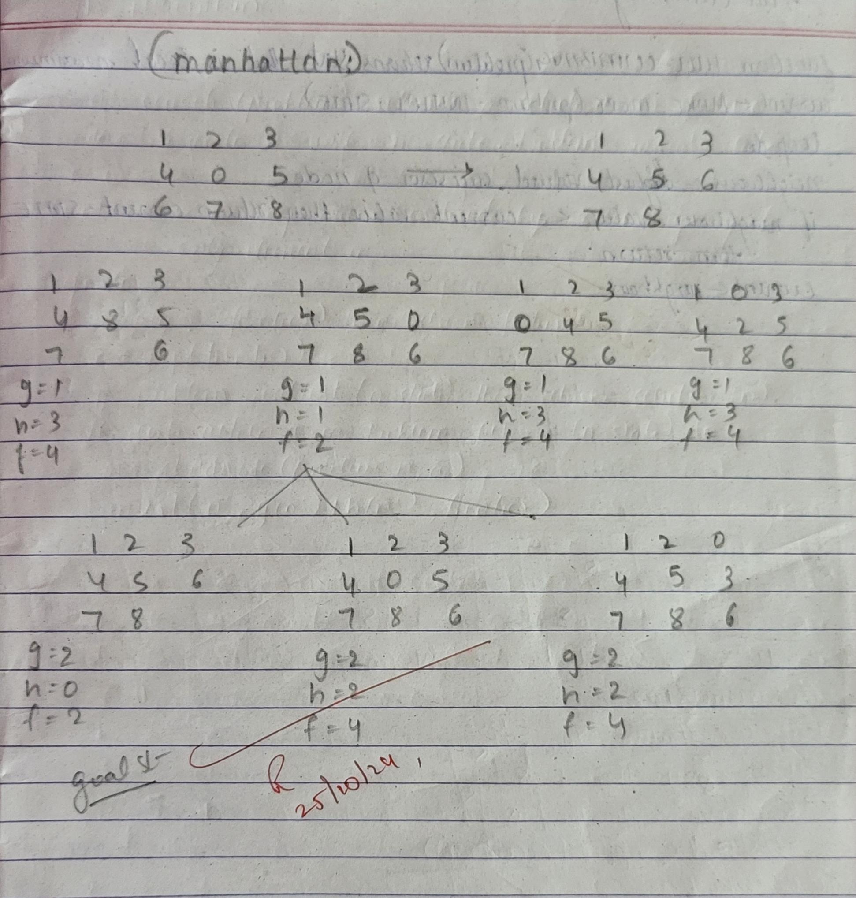

**Code:**

**Misplaced Tiles:**

import heapq

# Define the goal state as a tuple of tuples

GOAL_STATE = ((1, 2, 3),

(8, 0, 4),

(7, 6, 5))

# Heuristic: Count the number of misplaced tiles

def misplaced_tile(state):

misplaced = 0

for i in range(3):

for j in range(3):

if state[i][j] != 0 and state[i][j] != GOAL_STATE[i][j]:

misplaced += 1

return misplaced

# Find the position of the blank tile (0)

def find_blank(state):

for i in range(3):

for j in range(3):

if state[i][j] == 0:

return i, j

# Generate neighbors by moving the blank tile

def generate_neighbors(state):

neighbors = []

x, y = find_blank(state)

directions = [(0, 1), (0, -1), (1, 0), (-1, 0)] # Right, Left, Down, Up

for dx, dy in directions:

nx, ny = x + dx, y + dy

if 0 <= nx < 3 and 0 <= ny < 3:

# Create a new state by swapping tiles

new_state = [list(row) for row in state]

new_state[x][y], new_state[nx][ny] = new_state[nx][ny], new_state[x][y]

neighbors.append(tuple(tuple(row) for row in new_state))

return neighbors

# Reconstruct the path from the start state to the goal state

def reconstruct_path(came_from, current):

path = [current]

while current in came_from:

current = came_from[current]

path.append(current)

path.reverse()

return path

# A* search algorithm

def a_star(start):

open_list = []

heapq.heappush(open_list, (0 + misplaced_tile(start), 0, start)) # (f(n), g(n), state)

g_score = {start: 0} # Cost from start to the current state

came_from = {}

visited = set()

while open_list:

_, g, current = heapq.heappop(open_list)

# Check if we have reached the goal

if current == GOAL_STATE:

path = reconstruct_path(came_from, current)

return path, g

visited.add(current)

# Explore neighbors

for neighbor in generate_neighbors(current):

if neighbor in visited:

continue

tentative_g = g_score[current] + 1 # Each move has a cost of 1

# If this path is better, update scores and add to the queue

if tentative_g < g_score.get(neighbor, float('inf')):

came_from[neighbor] = current

g_score[neighbor] = tentative_g

f_score = tentative_g + misplaced_tile(neighbor) # f(n) = g(n) + h(n)

heapq.heappush(open_list, (f_score, tentative_g, neighbor))

return None, None # No solution found

# Print a given puzzle state

def print_state(state):

for row in state:

print(row)

print()

# Main function

if __name__ == "__main__":

start_state = ((2, 8, 3),

(1, 6, 4),

(7, 0, 5))

print("Initial State:")

print_state(start_state)

print("Goal State:")

print_state(GOAL_STATE)

solution, cost = a_star(start_state)

if solution:

print(f"Solution found with cost: {cost}")

print("Steps:")

for step in solution:

print_state(step)

else:

print("No solution found.")

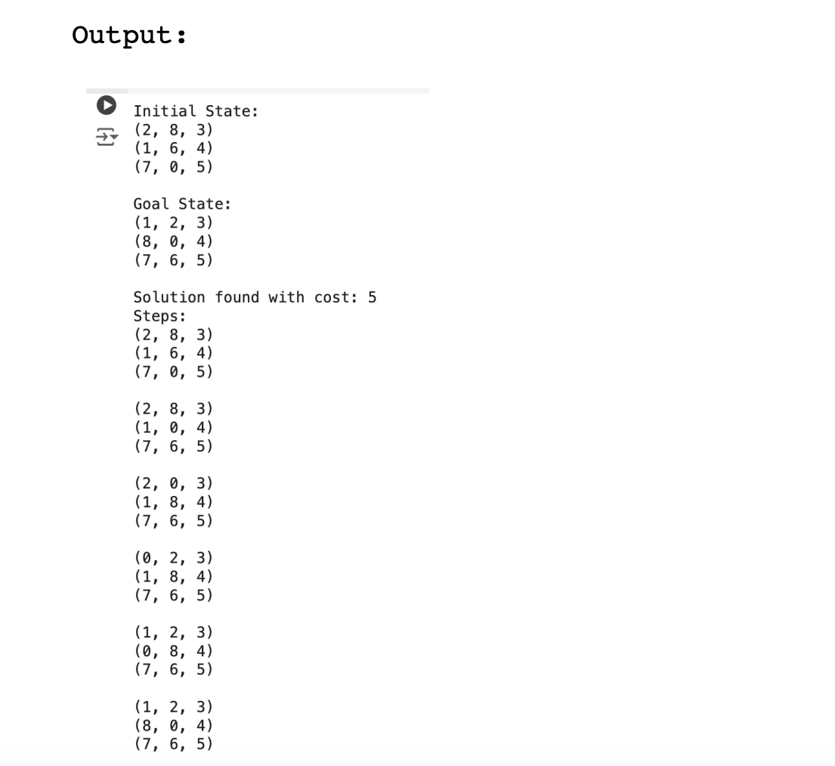

**Manhattan:**

import heapq

# Define the goal state as a tuple of tuples

GOAL_STATE = ((1, 2, 3),

(8, 0, 4),

(7, 6, 5))

# Heuristic: Calculate the Manhattan distance for each tile

def manhattan_distance(state):

distance = 0

for i in range(3):

for j in range(3):

value = state[i][j]

if value != 0:

goal_x, goal_y = divmod(value - 1, 3) # Find the goal position of the current tile

distance += abs(goal_x - i) + abs(goal_y - j)

return distance

# Find the position of the blank tile (0)

def find_blank(state):

for i in range(3):

for j in range(3):

if state[i][j] == 0:

return i, j

# Generate neighbors by moving the blank tile

def generate_neighbors(state):

neighbors = []

x, y = find_blank(state)

directions = [(0, 1), (0, -1), (1, 0), (-1, 0)] # Right, Left, Down, Up

for dx, dy in directions:

nx, ny = x + dx, y + dy

if 0 <= nx < 3 and 0 <= ny < 3:

# Create a new state by swapping tiles

new_state = [list(row) for row in state]

new_state[x][y], new_state[nx][ny] = new_state[nx][ny], new_state[x][y]

neighbors.append(tuple(tuple(row) for row in new_state))

return neighbors

# Reconstruct the path from the start state to the goal state

def reconstruct_path(came_from, current):

path = [current]

while current in came_from:

current = came_from[current]

path.append(current)

path.reverse()

return path

# A* search algorithm

def a_star(start):

open_list = []

heapq.heappush(open_list, (manhattan_distance(start), 0, start)) # (f(n), g(n), state)

g_score = {start: 0} # Cost from start to the current state

came_from = {}

visited = set()

while open_list:

f, g, current = heapq.heappop(open_list)

# Check if we have reached the goal

if current == GOAL_STATE:

path = reconstruct_path(came_from, current)

return path, g

visited.add(current)

# Explore neighbors

for neighbor in generate_neighbors(current):

if neighbor in visited:

continue

tentative_g = g_score[current] + 1 # Each move has a cost of 1

# If this path is better, update scores and add to the queue

if tentative_g < g_score.get(neighbor, float('inf')):

came_from[neighbor] = current

g_score[neighbor] = tentative_g

f_score = tentative_g + manhattan_distance(neighbor) # f(n) = g(n) + h(n)

heapq.heappush(open_list, (f_score, tentative_g, neighbor))

return None, None # No solution found

# Print a given puzzle state

def print_state(state):

for row in state:

print(row)

print()

# Main function

if __name__ == "__main__":

start_state = ((2, 8, 3),

(1, 6, 4),

(7, 0, 5))

print("Initial State:")

print_state(start_state)

print("Goal State:")

print_state(GOAL_STATE)

solution, cost = a_star(start_state)

if solution:

print(f"Solution found with cost: {cost}")

print("Steps:")

for step in solution:

print_state(step)

else:

print("No solution found.")

**Output:**

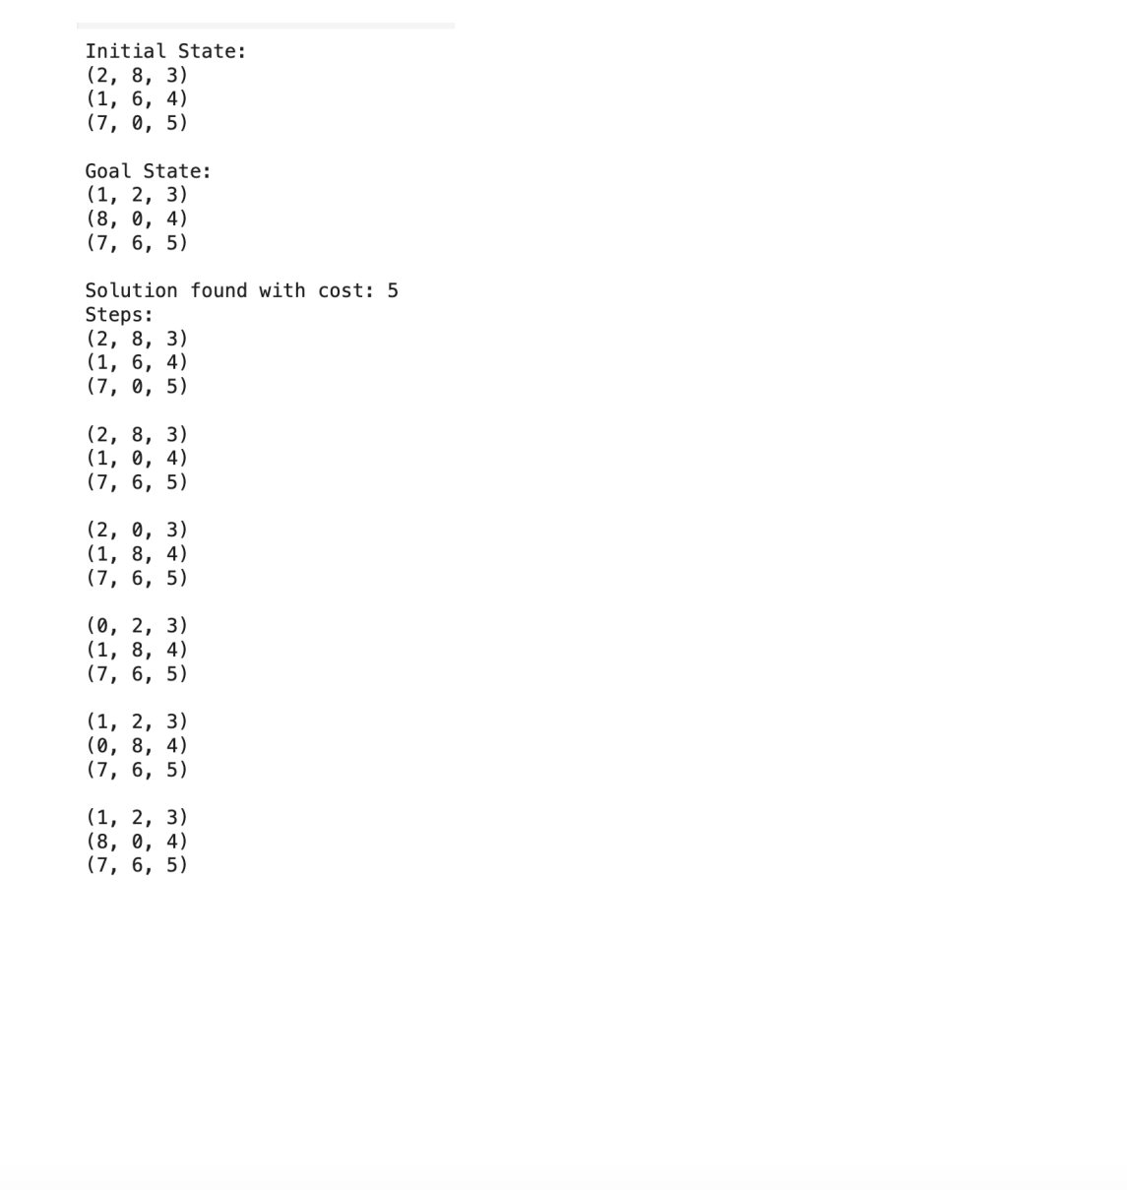

**Program 5**

**Implement Hill Climbing search algorithm to solve N-Queens problem**

**Algorithm:**

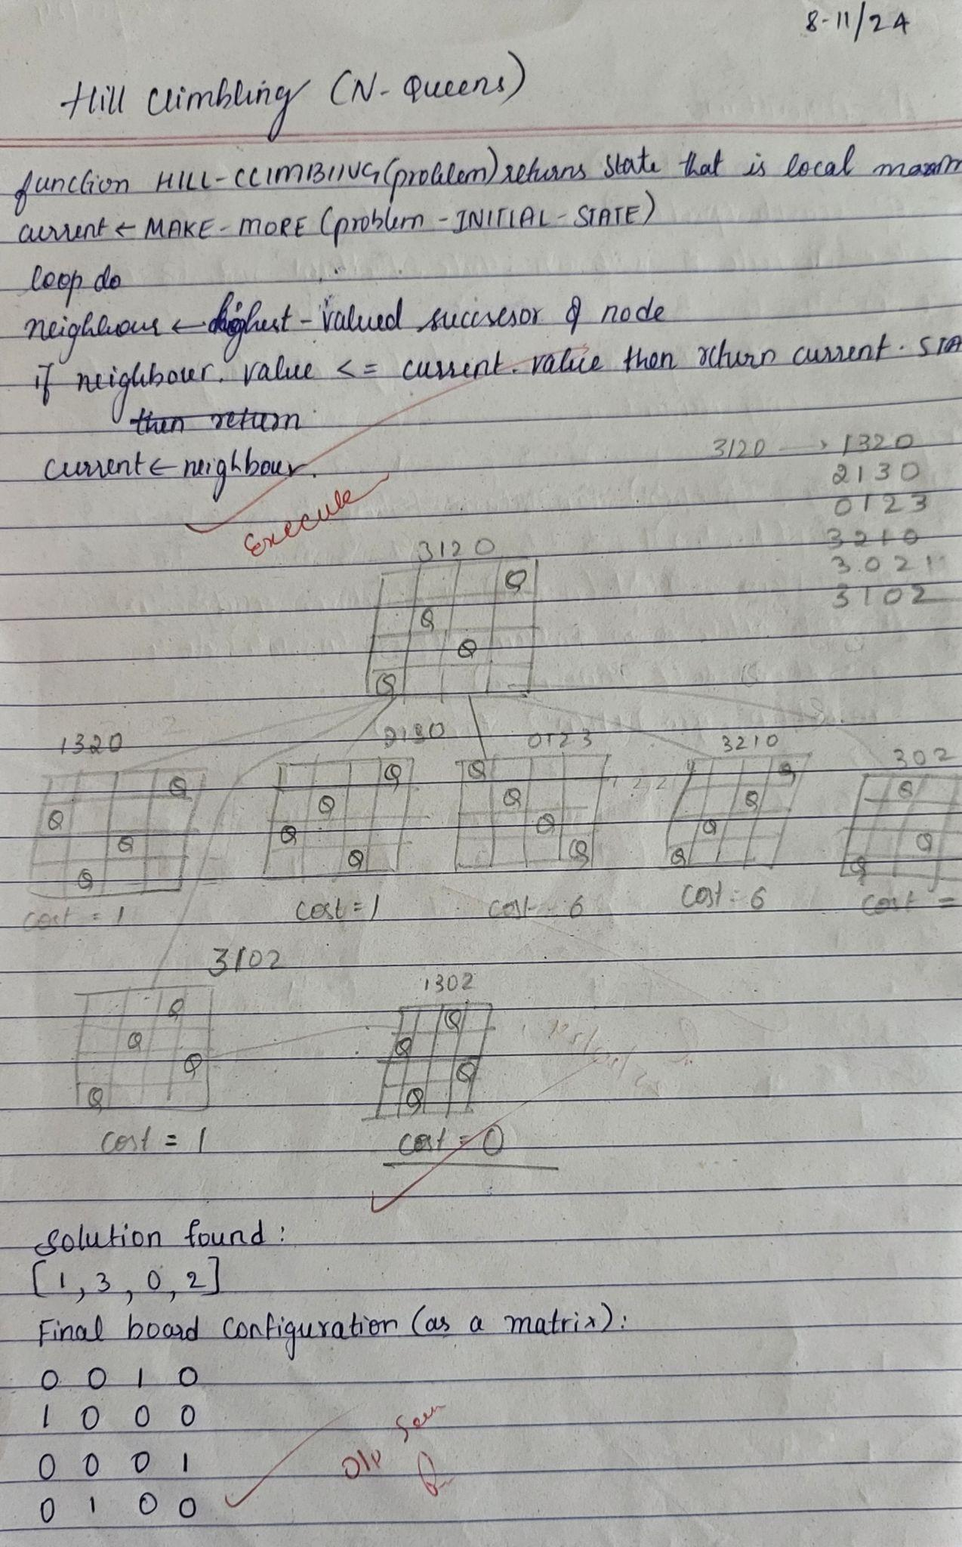

**Code:**

import random

def get_attacking_pairs(state):

"""Calculates the number of attacking pairs of queens."""

attacks = 0

n = len(state)

for i in range(n):

for j in range(i + 1, n):

# Check if queens are in the same column or diagonals

if state[i] == state[j] or abs(state[i] - state[j]) == abs(i - j):

attacks += 1

return attacks

def generate_successors(state):

"""Generates all possible successors by moving each queen to every other column in its row."""

n = len(state)

successors = []

for row in range(n):

for col in range(n):

if col != state[row]: # Only generate new states with different columns

new_state = state[:]

new_state[row] = col

successors.append(new_state)

return successors

def hill_climbing(n):

"""Hill climbing algorithm for N-Queens problem."""

# Start with a random state

current = [random.randint(0, n - 1) for _ in range(n)]

steps = 0

while True:

current_attacks = get_attacking_pairs(current)

successors = generate_successors(current)

# Find the neighbor with the minimum attacks

neighbor = min(successors, key=get_attacking_pairs)

neighbor_attacks = get_attacking_pairs(neighbor)

steps += 1

print(f"Step {steps}: Current State: {current}, Attacks: {current_attacks}")

# If no better neighbor is found, return the current state

if neighbor_attacks >= current_attacks:

return current, current_attacks

# Move to the better neighbor

current = neighbor

def print_board(state):

"""Prints the board with queens placed."""

n = len(state)

board = [["." for _ in range(n)] for _ in range(n)]

for row in range(n):

board[row][state[row]] = "Q"

for row in board:

print(" ".join(row))

print("\n")

# Set the size of the board

n = 8 # Change this value to test with different board sizes

solution, attacks = hill_climbing(n)

print("Final State (Solution):", solution)

print("Number of Attacking Pairs:", attacks)

print_board(solution)

**Output:**

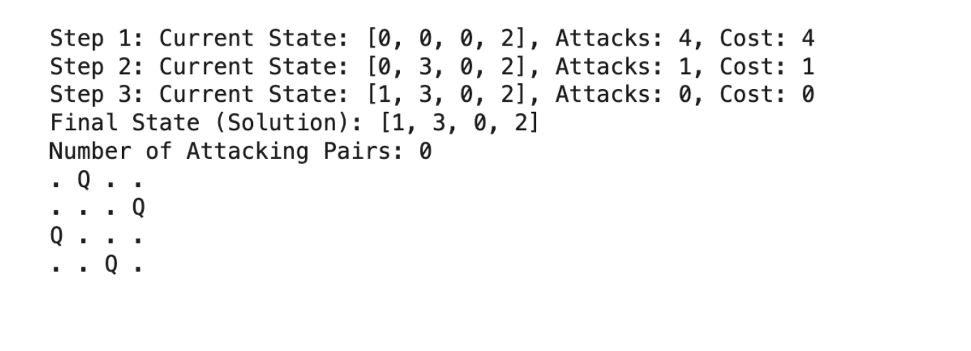

**Program 6**

**Simulated Annealing to Solve 8-Queens problem**

**Algorithm:**

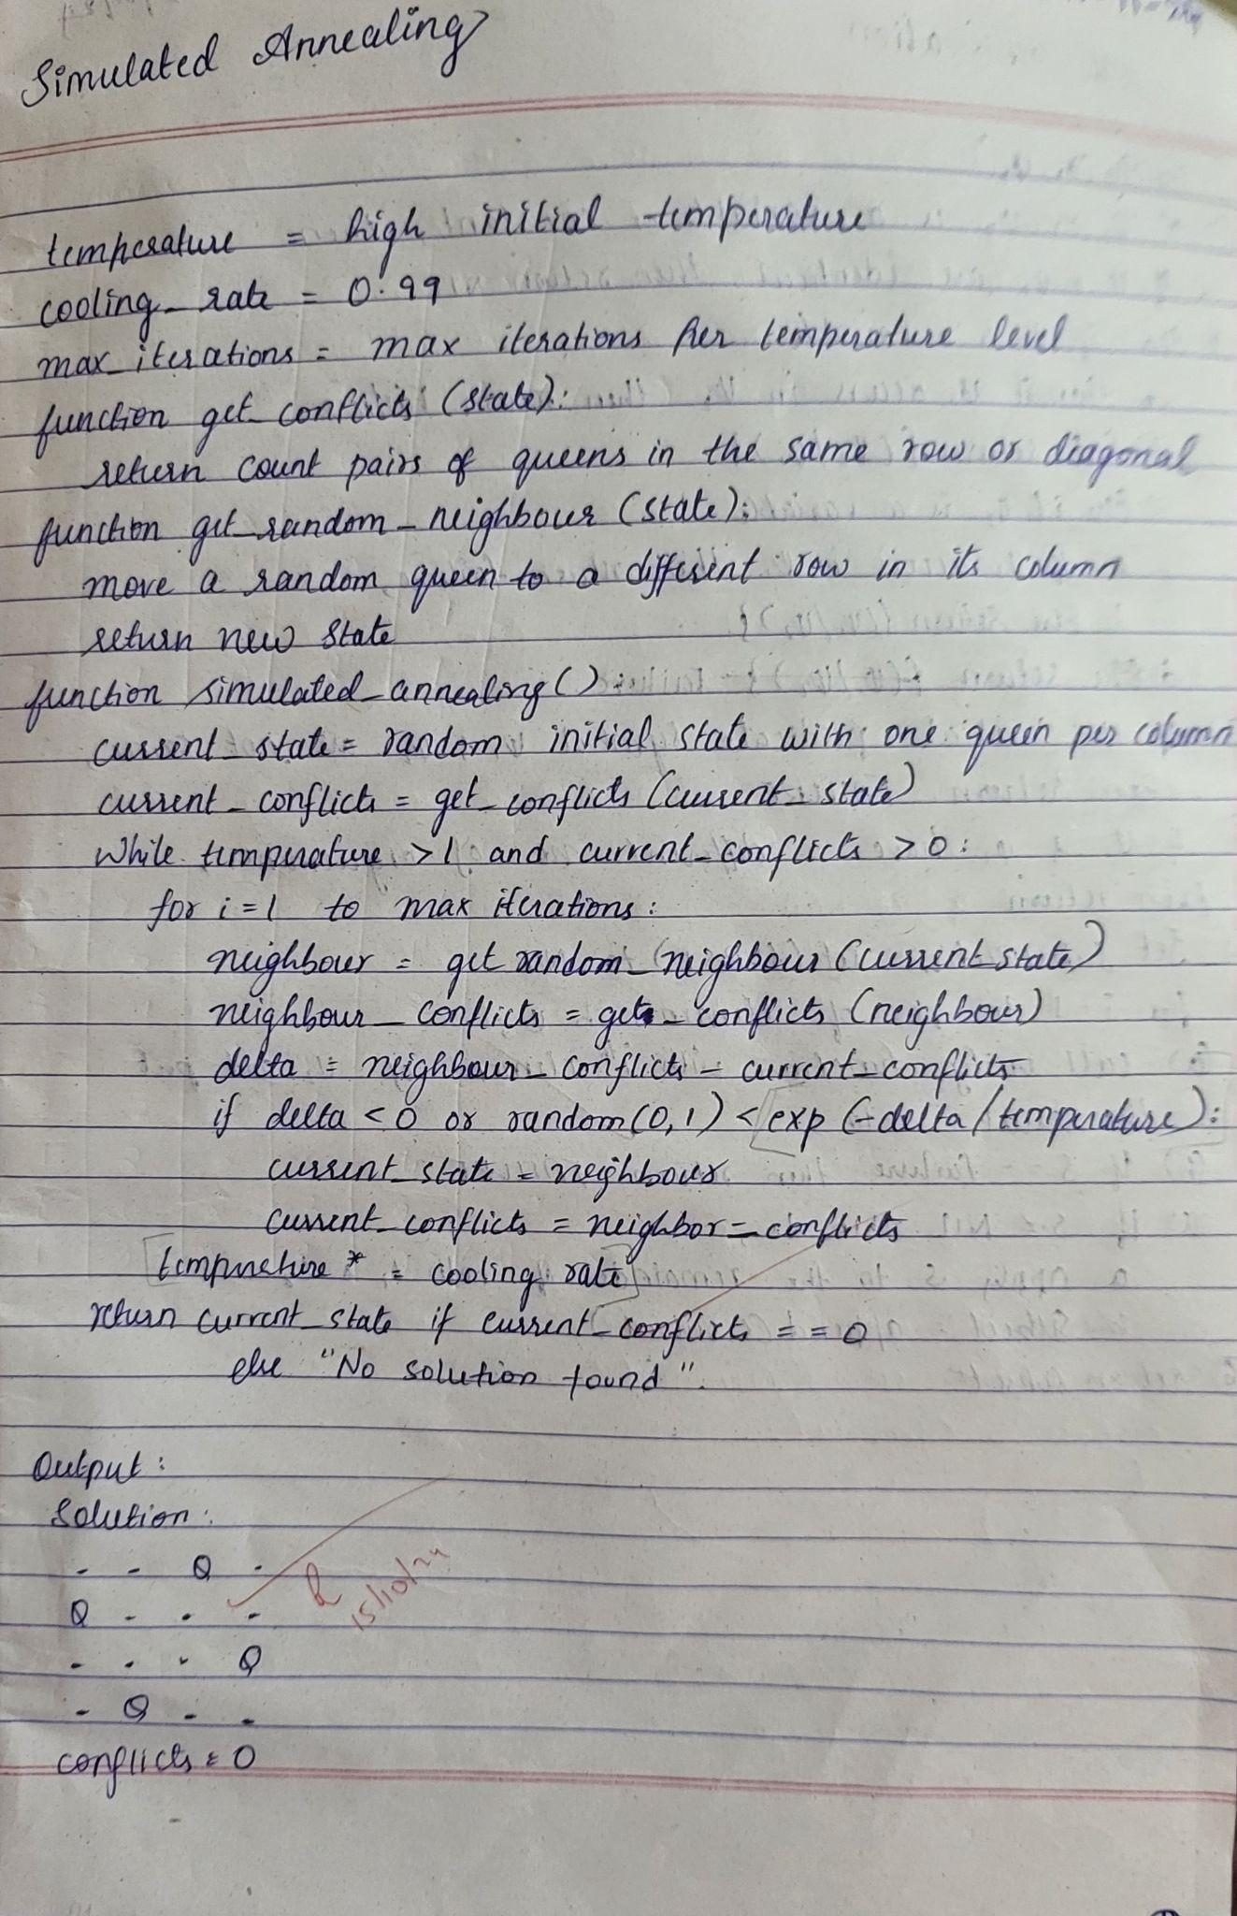

**Code:**

import numpy as np

from scipy.optimize import dual_annealing

def queens_max(position):

# This function calculates the number of pairs of queens that are not attacking each other

position = np.round(position).astype(int)

n = len(position)

queen_not_attacking = 0

for i in range(n - 1):

for j in range(i + 1, n):

# Check if queens i and j are not attacking each other

if position[i] != position[j] and abs(position[i] - position[j]) != (j - i):

queen_not_attacking += 1

return -queen_not_attacking # Return negative for maximization

# Bounds for each queen's position (0 to 7 for an 8x8 chessboard)

bounds = [(0, 7) for _ in range(8)]

# Use dual_annealing for simulated annealing optimization

result = dual_annealing(queens_max, bounds)

# Display the results

best_position = np.round(result.x).astype(int)

best_objective = -result.fun

print('The best position found is:', best_position)

print('The number of queens that are not attacking each other is:', best_objective)

**Output:**



Example: SUDOKU PROBLEM

import numpy as np

import random

import math

def is_valid(puzzle, row, col, num):

"""Check if a number can be placed at a specific position."""

if num in puzzle[row] or num in puzzle[:, col]:

return False

box_x, box_y = row // 3 * 3, col // 3 * 3

if num in puzzle[box_x:box_x + 3, box_y:box_y + 3]:

return False

return True

def initial_fill(puzzle):

"""Fill the empty cells in the puzzle with valid random values."""

filled = puzzle.copy()

for row in range(9):

for col in range(9):

if filled[row][col] == 0:

possible_values = [num for num in range(1, 10) if is_valid(filled, row, col, num)]

if possible_values:

filled[row][col] = random.choice(possible_values)

return filled

def objective(puzzle):

"""Calculate the number of conflicts in the Sudoku puzzle."""

conflicts = 0

# Row conflicts

for row in range(9):

conflicts += 9 - len(set(puzzle[row]))

# Column conflicts

for col in range(9):

conflicts += 9 - len(set(puzzle[:, col]))

# Box conflicts

for box_x in range(0, 9, 3):

for box_y in range(0, 9, 3):

box = puzzle[box_x:box_x+3, box_y:box_y+3].flatten()

conflicts += 9 - len(set(box))

return conflicts

def simulated_annealing(puzzle, max_iter=100000, start_temp=1.0, end_temp=0.01, alpha=0.99):

"""Solve the Sudoku puzzle using simulated annealing."""

current_state = initial_fill(puzzle)

current_score = objective(current_state)

temp = start_temp

for iteration in range(max_iter):

if current_score == 0: # Solution found

break

# Randomly pick an empty cell

row, col = random.randint(0, 8), random.randint(0, 8)

while puzzle[row][col] != 0:

row, col = random.randint(0, 8), random.randint(0, 8)

# Create a new state with a random value in the chosen cell

new_state = current_state.copy()

new_value = random.randint(1, 9)

if is_valid(new_state, row, col, new_value):

new_state[row][col] = new_value

new_score = objective(new_state)

delta_score = new_score - current_score

# Accept new state based on simulated annealing criteria

if delta_score < 0 or random.uniform(0, 1) < math.exp(-delta_score / temp):

current_state, current_score = new_state, new_score

# Decrease temperature

temp *= alpha

if temp < end_temp:

break

return current_state

# Example usage:

puzzle = np.array([

[5, 3, 0, 0, 7, 0, 0, 0, 0],

[6, 0, 0, 1, 9, 5, 0, 0, 0],

[0, 9, 8, 0, 0, 0, 0, 6, 0],

[8, 0, 0, 0, 6, 0, 0, 0, 3],

[4, 0, 0, 8, 0, 3, 0, 0, 1],

[7, 0, 0, 0, 2, 0, 0, 0, 6],

[0, 6, 0, 0, 0, 0, 2, 8, 0],

[0, 0, 0, 4, 1, 9, 0, 0, 5],

[0, 0, 0, 0, 8, 0, 0, 7, 9]

])

solved_puzzle = simulated_annealing(puzzle)

print("Solved Sudoku:\n", solved_puzzle)

**Output:**

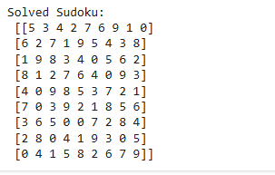

**Program 7**

**Implement unification in first order logic**

**Algorithm:**

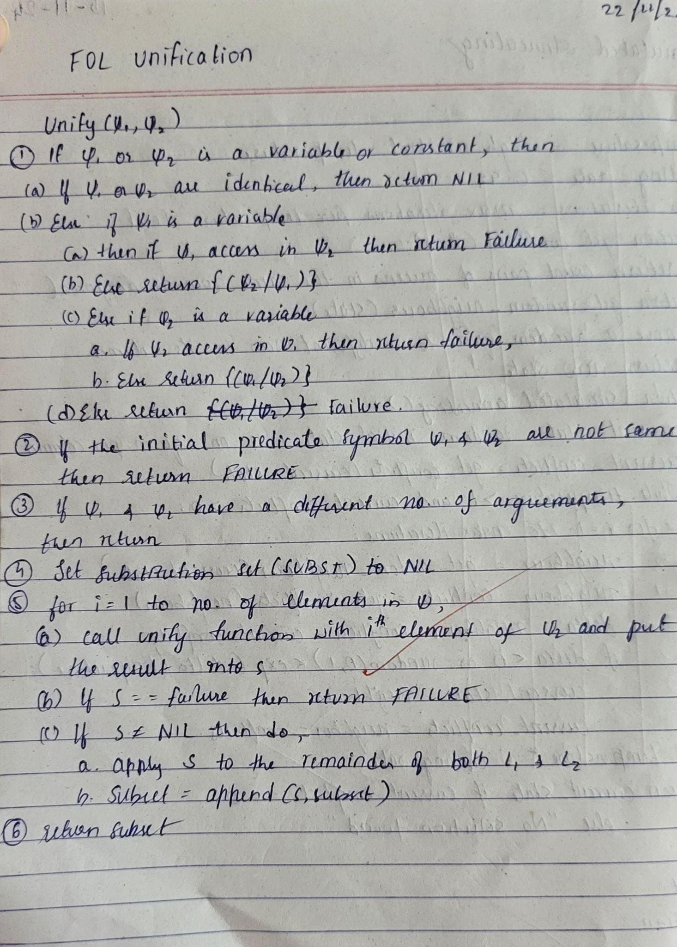

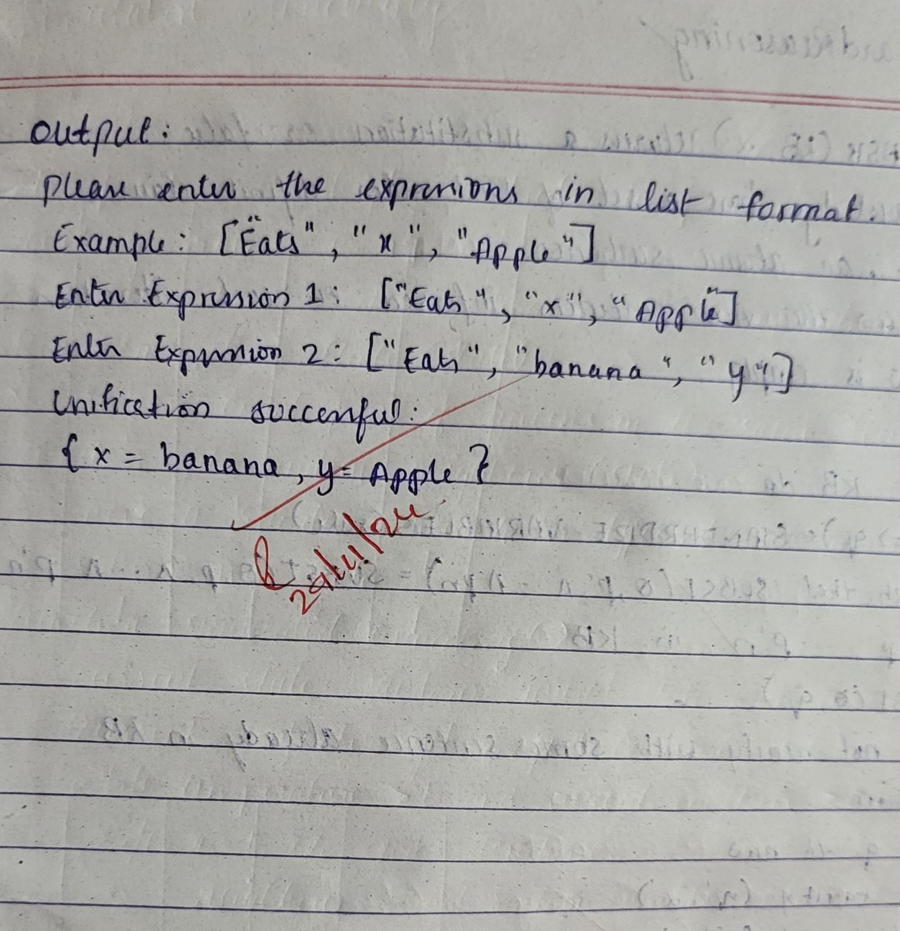

**Code:**

class UnificationError(Exception):

"""Custom exception for unification errors."""

pass

def occurs_check(var, term, subst):

"""Check if `var` occurs in `term` (to prevent circular substitutions)."""

if var == term:

return True

elif isinstance(term, (list, tuple)):

return any(occurs_check(var, t, subst) for t in term)

elif isinstance(term, str) and term in subst:

return occurs_check(var, subst[term], subst)

return False

def is_variable(term):

"""Check if `term` is a variable (starting with `?`)."""

return isinstance(term, str) and term.startswith('?')

def unify(psi1, psi2, subst=None):

"""Attempt to unify two terms, `psi1` and `psi2`, under the given substitution."""

if subst is None:

subst = {}

if psi1 == psi2:

return subst

elif is_variable(psi1):

if psi1 in subst:

return unify(subst[psi1], psi2, subst)

elif occurs_check(psi1, psi2, subst):

raise UnificationError(f"Occurs check failed: {psi1} in {psi2}")

else:

subst[psi1] = psi2

return subst

elif is_variable(psi2):

if psi2 in subst:

return unify(psi1, subst[psi2], subst)

elif occurs_check(psi2, psi1, subst):

raise UnificationError(f"Occurs check failed: {psi2} in {psi1}")

else:

subst[psi2] = psi1

return subst

elif isinstance(psi1, list) and isinstance(psi2, list):

if psi1[0] != psi2[0]:

raise UnificationError(f"Predicate symbols don't match: {psi1[0]} != {psi2[0]}")

if len(psi1) != len(psi2):

raise UnificationError(f"Argument lengths don't match: {len(psi1)} != {len(psi2)}")

for arg1, arg2 in zip(psi1[1:], psi2[1:]): # Skip the predicate symbol (first element)

subst = unify(arg1, arg2, subst)

return subst

else:

raise UnificationError(f"Cannot unify {psi1} with {psi2}")

def get_input():

"""Get input from the user and perform unification."""

try:

term1 = eval(input("Enter the first term (e.g., ['P', 'b', 'x', ['f', ['g', 'z']]]): "))

term2 = eval(input("Enter the second term (e.g., ['P', 'z', ['f', 'y'], ['f', 'y']]): "))

substitution = unify(term1, term2)

print("Unification successful!")

print("Substitution:", substitution)

except UnificationError as e:

print("Unification failed:", e)

except Exception as e:

print("Invalid input or error:", e)

# Run the unification input prompt

get_input()

**Output:**

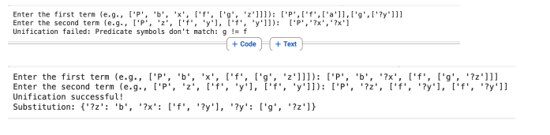

**Program 8**

**Create a knowledge base consisting of first order logic statements and prove the given query using Resolution**

**Algorithm:**

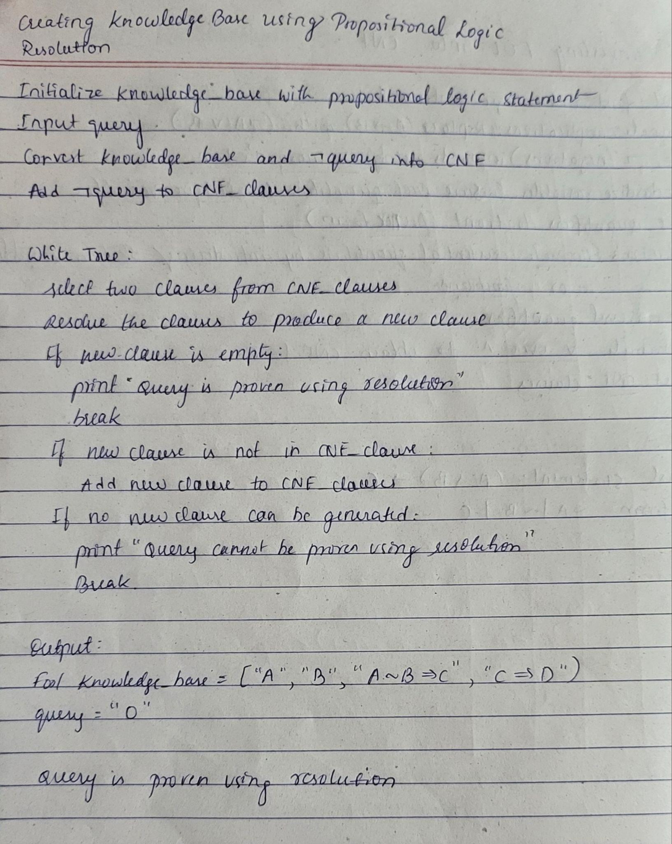

**Code:**

import re

class ForwardReasoning:

def __init__(self, rules, facts):

self.rules = rules # List of rules (condition -> result)

self.facts = set(facts) # Known facts

def match_condition(self, condition):

"""Check if all conditions match the current facts."""

variable_map = {}

for cond in condition:

fact_match = False

for fact in self.facts:

if self.match_fact(cond, fact, variable_map):

fact_match = True

break

if not fact_match:

return False, variable_map

return True, variable_map

def match_fact(self, cond, fact, variable_map):

"""Match a condition to a fact, handling variables."""

var_pattern = re.compile(r'\b\?[a-zA-Z]+\b') # Match variables starting with '?'

condition_parts = cond.split()

fact_parts = fact.split()

if len(condition_parts) != len(fact_parts):

return False

for cond_part, fact_part in zip(condition_parts, fact_parts):

if var_pattern.match(cond_part): # If it's a variable

if cond_part not in variable_map:

variable_map[cond_part] = fact_part

elif variable_map[cond_part] != fact_part:

return False

elif cond_part != fact_part: # If it's a constant, they must match

return False

return True

def infer(self, query):

"""Forward chaining algorithm to infer if the query can be derived."""

applied_rules = True

while applied_rules:

applied_rules = False

for condition, result in self.rules:

matched, variable_map = self.match_condition(condition)

if matched and result not in self.facts:

self.facts.add(result) # Add the result to known facts

applied_rules = True

print(f"Applied rule: {condition} -> {result}")

# If the query is inferred, return True immediately

if self.match_fact(query, result, variable_map):

return True

# Return True if the query is in facts after the reasoning process, else False

return query in self.facts

def get_input_rules():

"""Get input for rules from the user."""

rules = []

while True:

rule = input("Enter rule (or 'done' to finish): ").strip()

if rule.lower() == "done":

break

if "=>" in rule:

condition_str, result = rule.split("=>")

conditions = set(condition_str.strip().split(" AND "))

result = result.strip()

rules.append((conditions, result))

return rules

def get_input_facts():

"""Get input for facts from the user."""

facts = set()

while True:

fact = input("Enter fact (or 'done' to finish): ").strip()

if fact.lower() == "done":

break

facts.add(fact)

return facts

def get_input_query():

"""Get input for the query from the user."""

return input("Enter the query: ").strip()

# Main program to run the forward reasoning

def main():

print("Enter the rules:")

rules = get_input_rules()

print("\nEnter the facts:")

facts = get_input_facts()

print("\nEnter the query:")

query = get_input_query()

# Initialize and run forward reasoning

reasoner = ForwardReasoning(rules, facts)

result = reasoner.infer(query)

# Output results

print("\nFinal facts:")

print(reasoner.facts)

print(f"\nQuery '{query}' inferred: {result}")

# Call the main function to start

main()

**Output:**

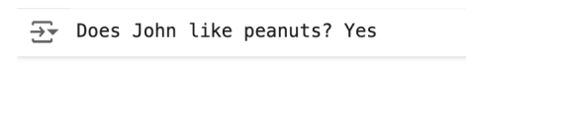

**Program 9**

**Forward Reasoning**:

**Algorithm:**

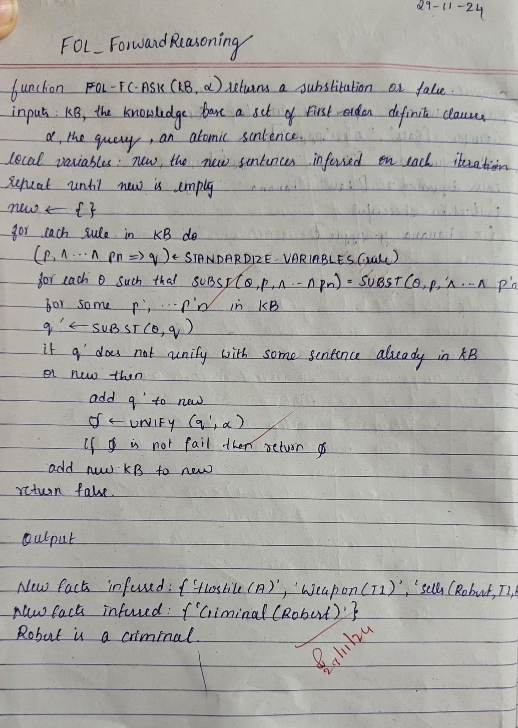

**Code:**

def fol_fc_ask(KB, query):

inferred = set() # Keep track of inferred facts

agenda = [fact for fact in KB if not fact.get('premises')] # Initial facts

rules = [rule for rule in KB if rule.get('premises')] # Rules with premises

# Debugging output

print(f"Initial agenda: {[fact['conclusion'] for fact in agenda]}")

print(f"Initial inferred: {inferred}")

while agenda:

fact = agenda.pop(0)

print(f"\nProcessing fact: {fact['conclusion']}")

# Check for query match

if fact['conclusion'] == query:

print(f"Found query match: {fact['conclusion']}")

return True

# Infer new facts if not already inferred

if fact['conclusion'] not in inferred:

inferred.add(fact['conclusion'])

print(f"Inferred facts: {inferred}")

# Process matching rules

for rule in rules:

if fact['conclusion'] in rule['premises']:

print(f"Rule premise satisfied: {rule['premises']} -> {rule['conclusion']}")

rule['premises'].remove(fact['conclusion']) # Remove satisfied premise

if not rule['premises']: # All premises satisfied

new_fact = {'conclusion': rule['conclusion']}

agenda.append(new_fact) # Add new fact to agenda

print(f"New fact inferred: {new_fact['conclusion']}")

# Debugging output after each iteration

print(f"Current agenda: {[fact['conclusion'] for fact in agenda]}")

print(f"Current inferred: {inferred}")

# If the loop finishes without finding the query

print(f"Query {query} not found.")

return False

# Example Knowledge Base

KB = [

{'premises': [], 'conclusion': 'American(Robert)'},

{'premises': [], 'conclusion': 'Missile(T1)'},

{'premises': [], 'conclusion': 'Owns(A, T1)'},

{'premises': [], 'conclusion': 'Enemy(A, America)'},

{'premises': ['Missile(T1)'], 'conclusion': 'Weapon(T1)'},

{'premises': ['American(Robert)', 'Weapon(T1)', 'Sells(Robert, T1, A)', 'Hostile(A)'], 'conclusion': 'Criminal(Robert)'},

{'premises': ['Owns(A, T1)', 'Enemy(A, America)'], 'conclusion': 'Hostile(A)'},

{'premises': [], 'conclusion': 'Sells(Robert, T1, A)'}

]

# Query

query = 'Criminal(Robert)'

# Run the algorithm

result = fol_fc_ask(KB, query)

print("Final Result:", result)

print("Tutari Likitha")

**Output:**

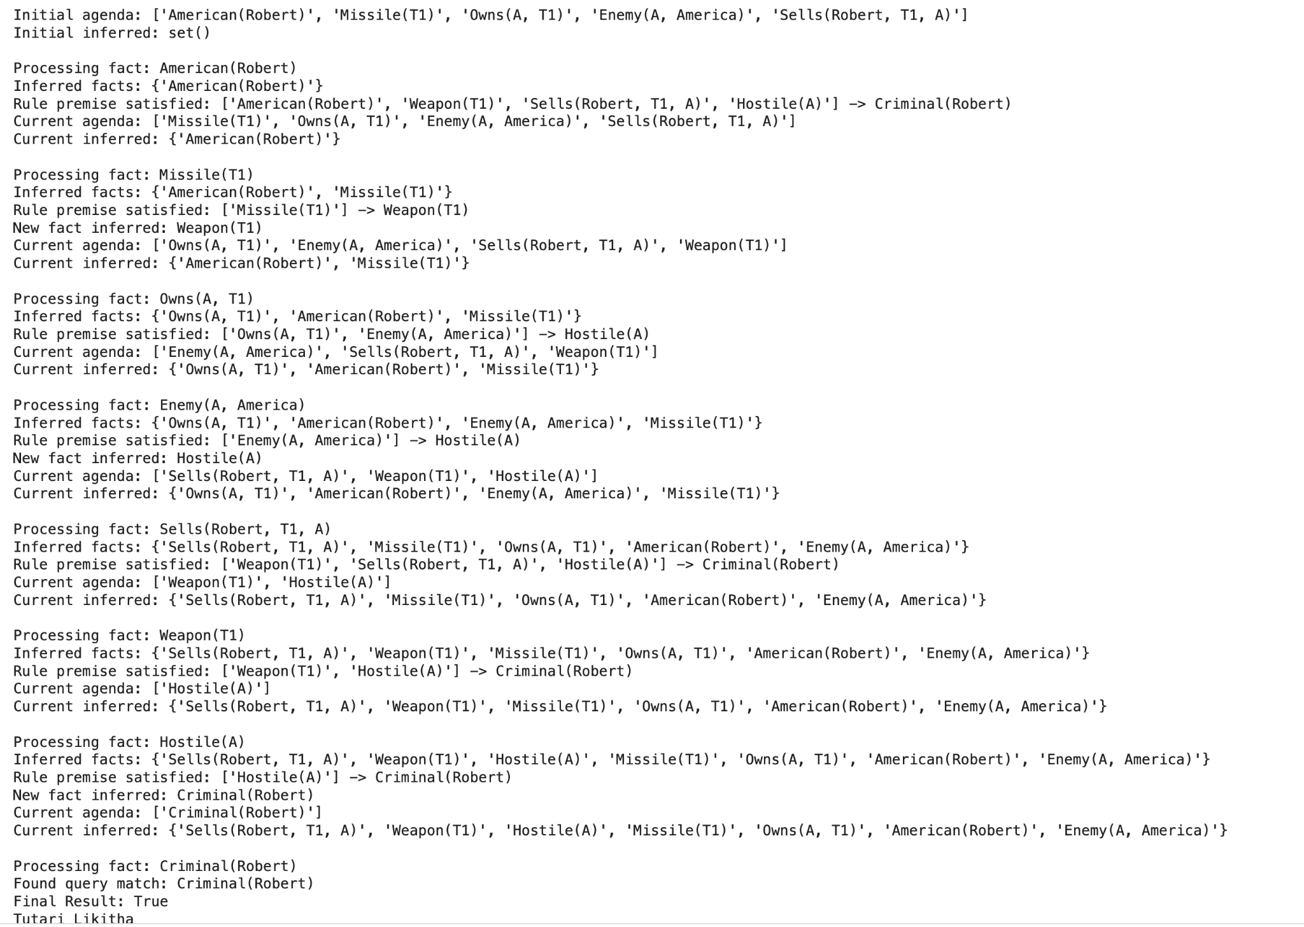

**Program 10**

**Converting FOL to CNF:**

**Algorithm:**

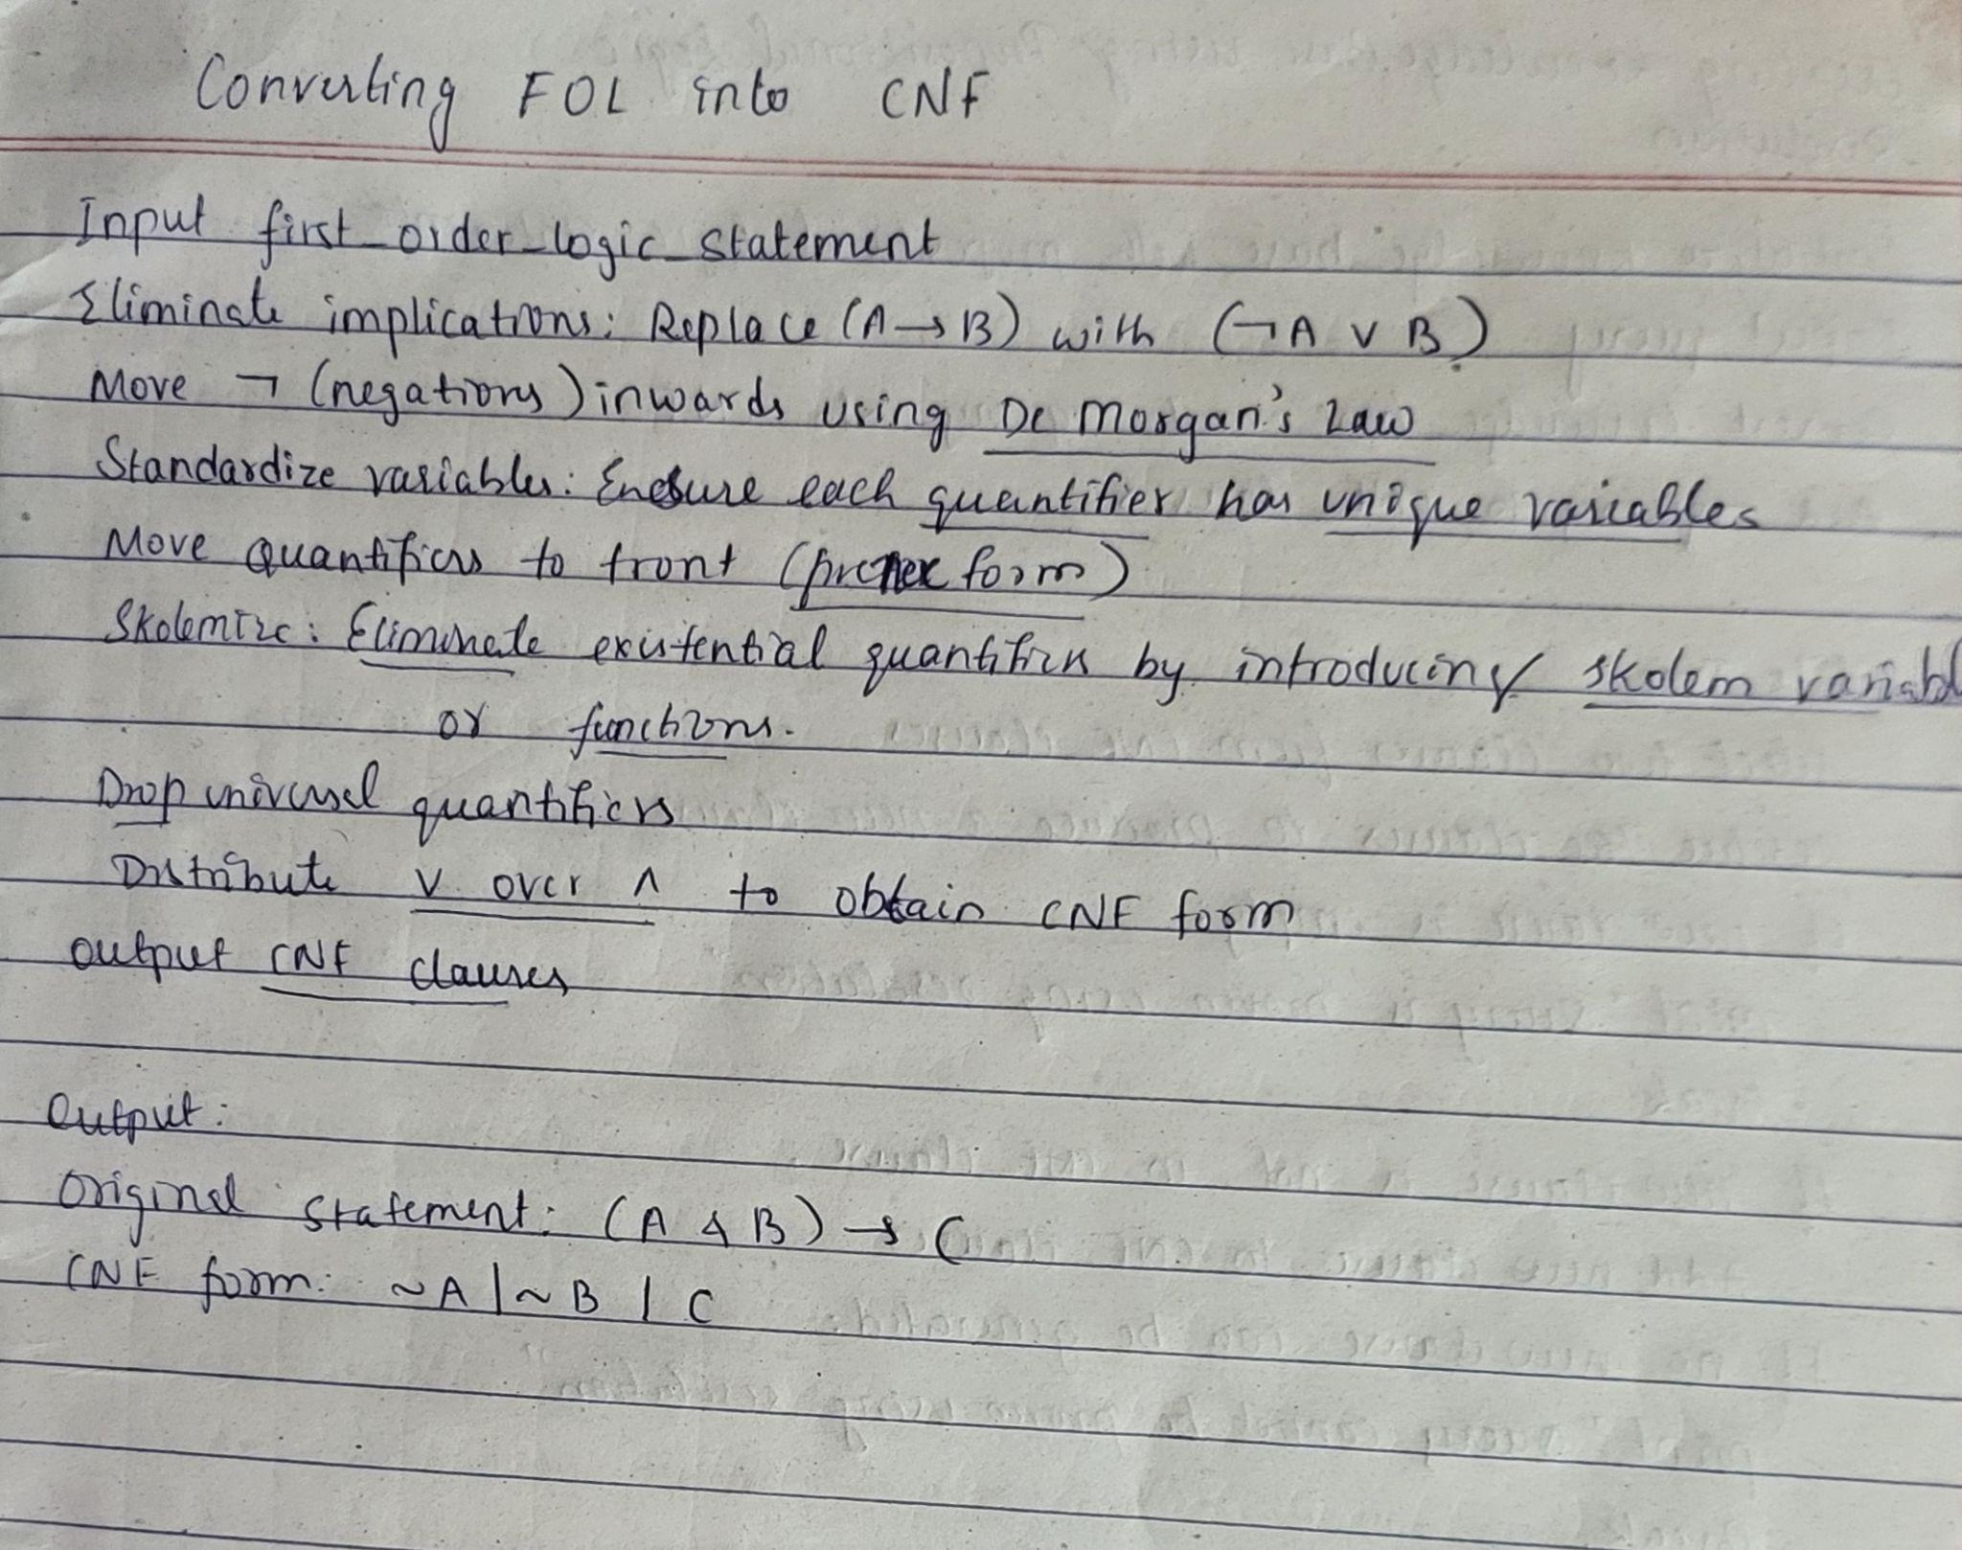

**Code:**

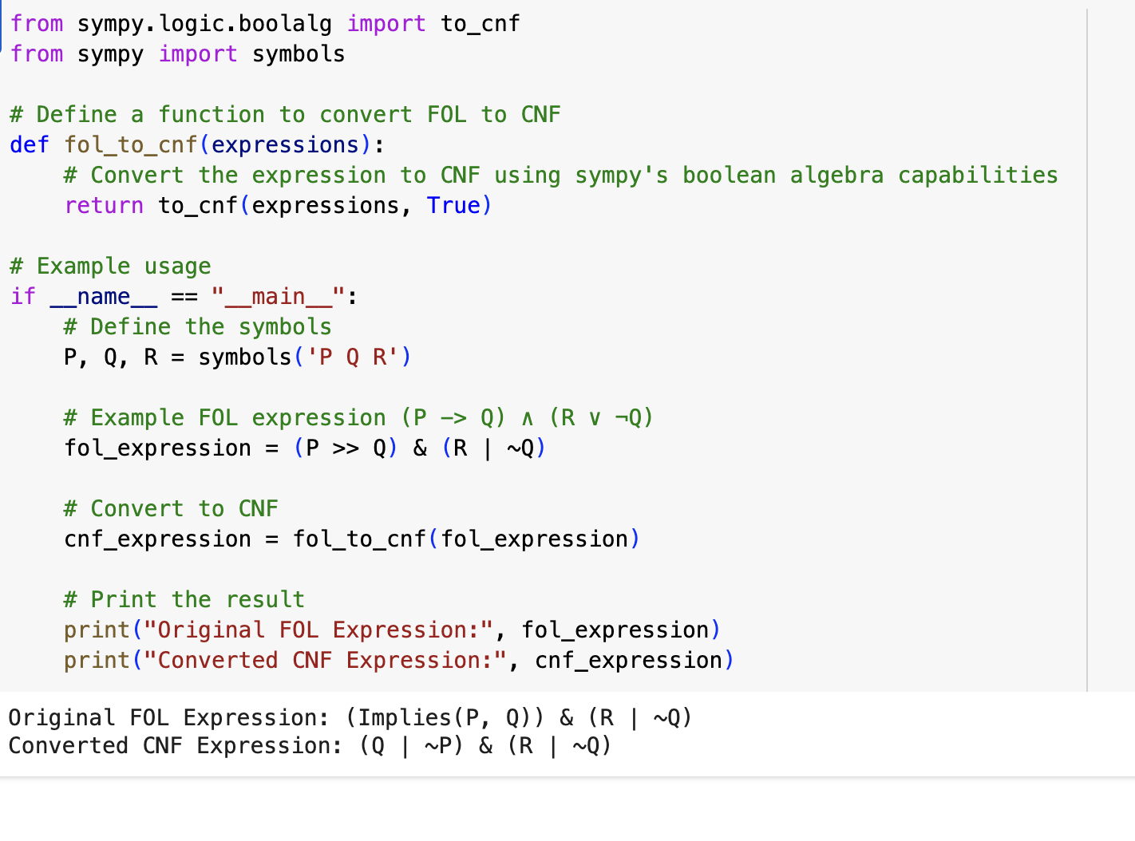

**Program 11:**

**Alpha Beta Pruning:**

**Algorithm:**

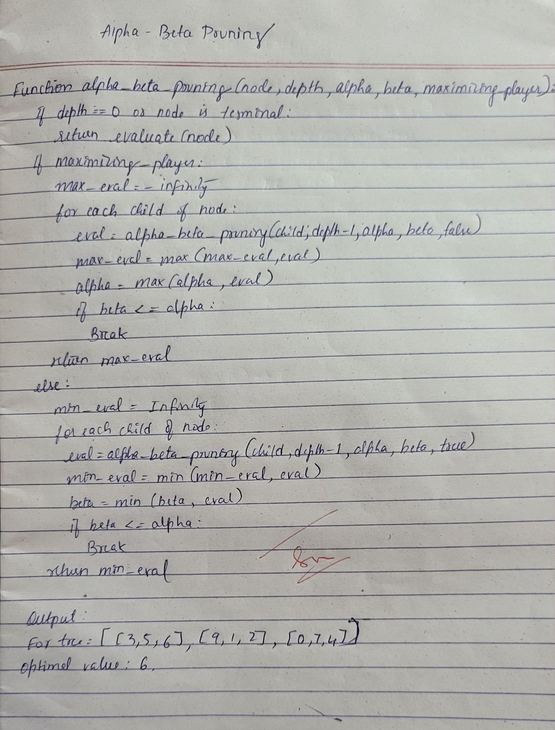

**Code:**

import math

def minimax(node, depth, is_maximizing):

"""

Implement the Minimax algorithm to solve the decision tree.

Parameters:

node (dict): The current node in the decision tree, with the following structure:

{

'value': int,

'left': dict or None,

'right': dict or None

}

depth (int): The current depth in the decision tree.

is_maximizing (bool): Flag to indicate whether the current player is the maximizing player.

Returns:

int: The utility value of the current node.

"""

# Base case: Leaf node

if node['left'] is None and node['right'] is None:

return node['value']

# Recursive case

if is_maximizing:

best_value = -math.inf

if node['left']:

best_value = max(best_value, minimax(node['left'], depth + 1, False))

if node['right']:

best_value = max(best_value, minimax(node['right'], depth + 1, False))

return best_value

else:

best_value = math.inf

if node['left']:

best_value = min(best_value, minimax(node['left'], depth + 1, True))

if node['right']:

best_value = min(best_value, minimax(node['right'], depth + 1, True))

return best_value

# Example usage

decision_tree = {

'value': 5,

'left': {

'value': 6,

'left': {

'value': 7,

'left': {

'value': 4,

'left': None,

'right': None

},

'right': {

'value': 5,

'left': None,

'right': None

}

},

'right': {

'value': 3,

'left': {

'value': 6,

'left': None,

'right': None

},

'right': {

'value': 9,

'left': None,

'right': None

}

}

},

'right': {

'value': 8,

'left': {

'value': 7,

'left': {

'value': 6,

'left': None,

'right': None

},

'right': {

'value': 9,

'left': None,

'right': None

}

},

'right': {

'value': 8,

'left': {

'value': 6,

'left': None,

'right': None

},

'right': None

}

}

}

# Find the best move for the maximizing player

best_value = minimax(decision_tree, 0, True)

print(f"The best value for the maximizing player is: {best_value}")

**Output:**

